|  |  |  |  |  |
| --- | --- | --- | --- | --- |
|  |  | | |  |
|  |  | | |  |
|  | Function Group Spec  Profile Settings Server - FnG  <<Logical>> (Allocated) | | |  |
|  |  |
|  |  |
|  |  | | |  |
| Document Type | **Function Specification** | | |  |
| Template Version | **6.0** | | |  |
| SysML Report Template Version | **O Beta (11/6/2019)** | | |  |
| Document ID | **VDOC089824 (VSEM ID F002032)** | | |  |
| Document Location | [**VSEM Link to Specification**](https://www.vsemweb.ford.com/tc/launchapp?-attach=true&-s=226TCSession&-o=1hsBES7Lx3NrTDAAAAAAAAAAAAA&servername=Production_Server) | | |  |
| Document Owner | **Justin Bauer, Walter Stephens** | | |  |
| Document Revision | **1.3** | | |  |
| Document Status | **Released** | | |  |
| Date Issued | **2021-09-15** | | |  |
| Date Revised | **2021-10-07** | | |  |
| Document Classification | GIS1 Item Number: | **27.60/35** | |  |
| GIS2 Classification: | **Confidential** | |
|  | | | | |
|  | | | | |
| Document Approval | | | | |
| Name | Role | | Email Confirmation | Date |
|  |  | |  |  |
|  |  | |  |  |

Auto-Generated by MagicDraw

Printed Copies are Uncontrolled

# Disclaimer

**This document contains Ford Motor Company Confidential information. Disclosure of the information contained in any portion of this document is not permitted without the expressed, written consent of a duly authorized representative of Ford Motor Company, Dearborn, Michigan, U.S.A.**

**Copyright, Ó 2016 Ford Motor Company**

This document contains information developed and accumulated by and for FORD MOTOR COMPANY. As such, it is a proprietary document, which, if disseminated to unauthorized persons, would provide others with restricted information, data, or procedures not otherwise available, exposing the FORD MOTOR COMPANY to potential harm.

Employees and suppliers having custody of this specification or authorized to use it must be cognizant of its proprietary nature and ensure that the information herein is not made available to unauthorized persons.

FORD MOTOR COMPANY reserves the right to protect this work as an unpublished copyrighted work in the event of an inadvertent or deliberate unauthorized publication. FORD MOTOR COMPANY also reserves its rights under copyright laws to protect this work as a published work.

This document or portions thereof shall not be distributed outside FORD MOTOR COMPANY without prior written consent. Refer all questions concerning disclosure to the author(s) or to any duly authorized representative of Ford Motor Company.

# Contents

Table of Contents

Disclaimer 2

Contents 3

1 Introduction 5

1.1 Document Purpose 5

1.2 Document Scope 5

1.3 Document Audience 5

1.3.1 Stakeholder List 5

1.4 Document Organization 5

1.4.1 Document Context 5

1.4.2 Document Structure 5

1.5 Document Conventions 6

1.5.1 Requirements Templates 6

2 Function Group Description 7

3 Functional Architecture 8

3.1 Description 8

3.2 Function List 8

3.3 Signal List 8

4 Function Specifications 9

4.1 -329216010.jpg Execute Profile Settings 9

4.1.1 Function Overview 9

4.1.2 Function Scope 9

4.1.3 Function Interfaces 12

4.1.4 Function Modeling 14

4.1.5 Function Requirements 16

4.2 -329216010.jpg Send Changed Profile Setting 20

4.2.1 Function Overview 20

4.2.2 Function Scope 20

4.2.3 Function Interfaces 21

4.2.4 Function Modeling 22

4.2.5 Function Requirements 23

4.3 -329216010.jpg Send Profile Settings 25

4.3.1 Function Overview 25

4.3.2 Function Scope 25

4.3.3 Function Interfaces 27

4.3.4 Function Modeling 28

4.3.5 Function Requirements 30

4.4  Activate Passenger Profile 33

4.4.1 Function Overview 33

4.4.2 Function Scope 34

4.4.3 Function Interfaces 35

4.4.4 Function Modeling 36

4.4.5 Function Requirements 36

4.5  Store passenger seat from Infotainment Request - Passenger Seat Module Only 38

4.5.1 Function Overview 38

4.5.2 Function Scope 39

4.5.3 Function Interfaces 41

4.5.4 Function Modeling 42

4.5.5 Function Requirements 42

5 Open Concerns 44

6 Revision History 45

7 Appendix 46

7.1 Data Dictionary 46

7.1.1 Logical Signals 46

7.1.2 Logical Parameters 49

7.1.3 Encoding Types 50

7.2 Glossary 50

7.2.1 Definitions 50

7.2.2 Abbreviations 51

**List of Figures**

Figure 1: Functional Decomposition 7

Figure 2: Activity Diagram of -1287594147.jpg “1 Link New Vehicle Profile w/ FP Account” calling -329216010.jpg “Execute Profile Settings” 10

Figure 3: Activity Diagram of -1287594147.jpg “2 Link Pre-existing Vehicle Profile w/ FP account” calling -329216010.jpg “Execute Profile Settings” 11

Figure 4: Activity Diagram of -1287594147.jpg “15 Restore Changed Profile” calling -329216010.jpg “Execute Profile Settings” 11

Figure 5: Activity Diagram of -1287594147.jpg “16 Update Profile in Vehicle” calling -329216010.jpg “Execute Profile Settings” 12

Figure 6: Execute Profile Settings Activity Diagram 14

Figure 7: Execute Profile Settings Sequence Diagram 15

Figure 8: Execute Profile Settings - FAILED Sequence Diagram 15

Figure 9: Execute Profile Settings - INVALID Sequence Diagram 15

Figure 10: Activity Diagram of -1287594147.jpg “7 Synchronize Profile with the Cloud” calling -329216010.jpg “Send Changed Profile Setting” 21

Figure 11: Send Changed Profile Setting 22

Figure 12: Send Changed Profile Setting Sequence Diagram 23

Figure 13: Activity Diagram of -1287594147.jpg “1 Link New Vehicle Profile w/ FP Account” calling -329216010.jpg “Send Profile Settings” 26

Figure 14: Activity Diagram of -1287594147.jpg “2 Link Pre-existing Vehicle Profile w/ FP account” calling -329216010.jpg “Send Profile Settings” 27

Figure 15: Activity Diagram of -1287594147.jpg “7 Synchronize Profile with the Cloud” calling -329216010.jpg “Send Profile Settings” 27

Figure 16: Send Profile Settings 29

Figure 17: Send All Profile Settings Sequence Diagram 30

Figure 18: Send One Profile Setting Sequence Diagram 30

Figure 19 Activity Diagram of  “Recall Passenger Profile - Re-Entry” calling  “Activate Passenger Profile” 34

Figure 20: Activity Diagram of 1971981308.jpg “Reload Passenger Seat Position” calling  “Activate Passenger Profile” 35

Figure 21: Activity Diagram of  “Create Passenger Profile via HMI - First Entry” calling  “Store passenger seat from Infotainment Request - Passenger Seat Module Only” 40

Figure 22: Activity Diagram of 1971981308.jpg “Manual Save Passenger Seat Position” calling 1179395554.jpg “Store passenger seat from Infotainment Request - Passenger Seat Module Only” 41

# Introduction

## Document Purpose

The Function (Group) Specification (FS) specifies an individual function / a group of functions.

To get more information about the concept of feature, function and component level abstraction refer to the [Ford RE Wiki](http://wiki.ford.com/display/RequirementsEngineering/Requirements+Engineering+for+SW+Enabled+Features).

## Document Scope

The following set of functions from the [Global Feature & Function List](https://www.vsemweb.ford.com:443/tc/launchapp?-attach=true&-s=226TCSession&-o=ZmZNi0JHx3NrTDAAAAAAAAAAAAA) is described in this specification.

|  |  |  |  |
| --- | --- | --- | --- |
| **Function ID** | **Function Name** | **Owner** | **Reference** |
| Fn012421 | Send Profile Settings | Jbauer50 |  |
| Fn012438 | Send Changed Profile Setting | Jbauer50 |  |
| Fn012467 | Execute Profile Settings | Jbauer50 |  |
|  | Activate Passenger Profile | Jbauer50 |  |
|  | Store Passenger seat from Infotainment Request – Passenger Seat Module Only | Jbauer50 |  |

**Table 1: Functions described in this specification**

## Document Audience

The FS is authored by the owners of the individual functions. All Stakeholders, i.e., all people who have a valid interest in the functions and their behavior should read and, if possible, review the FS. It needs to be guaranteed, that all stakeholders have access to the currently valid version of the FS.

**#Hint:** The FS template has the IP Classification “Proprietary” by default. IP Classification “Confidential” might be required in some cases, e.g. by Ford Functional Safety.

### Stakeholder List

For the latest list of the feature stakeholder and their roles & responsibilities refer to [PPP Stakeholder List](https://www.vsemweb.ford.com/tc/launchapp?-attach=true&-s=226TCSession&-o=S5U9Hrgbx3NrTDAAAAAAAAAAAAA&servername=Production_Server)

**#Hint:** Refer to [Ford RE Wiki – Stakeholder List](http://wiki.ford.com/display/RequirementsEngineering/Stakeholder+Analysis) on how to create a stakeholder list. The stakeholder list should be stored in VSEM in the pseudo folder “General Data Artifacts” of the corresponding function.

## Document Organization

### Document Context

Refer to the [Specification Structure page](http://wiki.ford.com/display/RequirementsEngineering/Specification+templates) in the [Ford RE Wiki](http://wiki.ford.com/display/RequirementsEngineering/Requirements+Engineering+for+SW+Enabled+Features) to understand how the FS relates to other Ford Requirements Documents and Specifications.

### Document Structure

The structure of this document is explained below:

**Section 1** – Introduction how to use this document including responsibilities and requisite documents. Explains the terminology. Gives a clarification of the definitions, concepts and abbreviations used in the document.

**Section 2** – Function Group Description. Gives an overview and the purpose of the function group.

**Section 3** – Functional Architecture: Specifies the overall functional architecture of the function group

**Section 4** – Function Specifications: Specifies the logical functions of the function group in detail

**Section 5** – List of Open Concerns

**Section 6** Revision history including a list of new or modified requirements. The requirements in this document are tagged, and this section contains different types of tables listing all, new, or changed requirements by their title and page no.

**Section 7** – Appendix: Presenting additional data mainly in a tabular form, e.g., a data dictionary

**#Hint:** All sections are mandatory, unless explicitly marked by the tag “#Classification” as “optional” or as applicable e.g. to certain domains like “Functional Safety”.

## Document Conventions

### Requirements Templates

Each requirement, use case or scenario in this specification shall follow the corresponding template given in the document template *Specification_Macros.dotm* at [RE Wiki - Specification Templates](http://wiki.ford.com/display/RequirementsEngineering/Specification+templates?src=contextnavpagetreemode).

#### Identification of Requirements

#### Requirements Attributes

The templates provided by *Specification_Macros.dotm* define a list of attributes for each requirement. This helps to classify the requirement. The attributes are explained at [RE Wiki - Requirements Attributes](http://wiki.ford.com/display/RequirementsEngineering/Requirements+Attributes?src=contextnavpagetreemode).

# Function Group Description

**#Classification:** Function Group only (remove section, if only a single Function is specified in this document)

**#Hint**: Provide an overview / a description of the Function Group

This Function Group consists of all functions allocated to -231321925.jpg **Profile Settings Server - FnG** <<Logical>> including all functions in their corresponding call trees.

Description of Profile Settings Server - FnG:

The Profile Setting Server logical block is a generic term for any vehicle module that owns the execution and storage of profile settings. The scope of the logical block is how each module interacts with the Profile System, and not with the customer. This specification describes the general design each Profile Setting Server must follow to enable Personal and Portable Profiles.

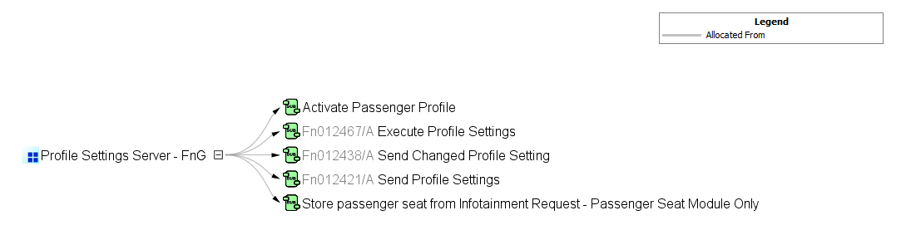

Figure : Functional Decomposition

# Functional Architecture

**#Classification:** Function Group only (remove section, if only a single Function is specified in this document)

**#Hint:** The Functional Architecture shall reflect the result of the functional decomposition for a given feature or parts of it.

Refer to the [*RE Wiki – Functional Decomposition*](http://wiki.ford.com/display/RequirementsEngineering/Functional+Analysis+and+Architecture) for some guidance on how to decompose a feature into functions, i.e., how to find the right functional partitioning for the function level. The functions shown here are those, which are specified in section 5 “Function Specifications”.

## Description

**#Hint:** Provide some informal description of the characteristics of the chosen architecture. Also give some graphical representation of the Functional Architecture. Either SysML Internal Block diagrams or [Data Flow Diagrams](http://wiki.ford.com/display/RequirementsEngineering/Data+Flow+Diagram?src=contextnavpagetreemode) could be used to depict such a Functional Architecture.

**#Link:** [*SysML – Internal Block Diagrams*](https://pd3.spt.ford.com/sites/SystemsEngineering/SEC/sysml-teamsite/SysML%20Wiki/Internal%20Block%20Diagram%20Basics.aspx) or [*RE Wiki - Data Flow Diagrams*](http://wiki.ford.com/display/RequirementsEngineering/Data+Flow+Diagram?src=contextnavpagetreemodehttp://wiki.ford.com/display/RequirementsEngineering/Data+Flow+Diagram?src=contextnavpagetreemode)

## Function List

|  |  |  |  |
| --- | --- | --- | --- |
| **Function ID** | **Function Name** | **Function Description** | **ASIL** |
| Fn012421/A | -329216010.jpg Send Profile Settings <<Subsystem Function>> | This function sends profile data associated to a user profile that is stored on the Profile Setting Server to the Profile Management Server when the PPPSettings_Rq with OperationCode = QUERY is received. The received query operation can be for a specific Feature Number or can be a batch query (FeatureNumber = NULL in PPPSettings_Rq) of all profile data associated to a profile. |  |
| Fn012438/A | -329216010.jpg Send Changed Profile Setting <<Subsystem Function>> | A function of the Profile Setting Servers that sends a change notification to the Profile Management Server when a change is made to a profile setting of an active profile. The notification does not determine which profile setting was changed, just that a change occurred and the Profile Management Server must query the active profile to refresh the local copy. |  |
| Fn012467/A | -329216010.jpg Execute Profile Settings <<Subsystem Function>> | This is a function of the Profile Setting Servers with the purpose of receiving and applying profile settings that are sent by the Profile Management Server. This function executes profile settings using Feature Number, Feature Value and Pers Index as inputs. The Profile Setting Servers utilize this function when receiving OperationCode = SET from Profile Management Server. |  |
|  | -1305462996.jpg Activate Passenger Profile <<Subsystem Function>> | Action taken by the Profile Setting Server when a Passenger Profile Activation request has been received. |  |
|  | -1305462996.jpg Store passenger seat from Infotainment Request - Passenger Seat Module Only <<Subsystem Function>> | Function that stores the current seat position to the requested PersIndex when the InfotainmentPsngrPersStore_Rq is received. |  |

Table 2: List of Logical Functions

## Signal List

Refer to the Data Dictionary - Logical Signals.

# Function Specifications

## -329216010.jpg Execute Profile Settings

### Function Overview

#### Description

Function is allocated to:

* -231321925.jpg Profile Settings Server - FnG <<Logical>>

This is a function of the Profile Setting Servers with the purpose of receiving and applying profile settings that are sent by the Profile Management Server. This function executes profile settings using Feature Number, Feature Value and Pers Index as inputs. The Profile Setting Servers utilize this function when receiving OperationCode = SET from Profile Management Server.

#### Variants

*Not supported by MagicDraw report generation.*

#### Input Requirements

*Not supported by MagicDraw report generation.*

#### Assumptions

No assumptions specified for this function.

#### References

##### Ford Documents

List here all Ford internal documents, which are directly related to the feature.

| **Reference** | **Title** | **Doc. ID** | **Revision** |
| --- | --- | --- | --- |
|  | Enhanced Memory Feature Specification | VDOC041625 | V3.1 |

Table 3: Ford internal Documents *(not specified in model)*

##### External Documents and Publications

The list of external documents could include books, reports and online sources.

| **Reference** | **Document / Publication** |
| --- | --- |
|  |  |

Table 4: External documents and publications *(not specified in model)*

#### Glossary

See Appendix for Definitions and Abbreviations.

### Function Scope

The -329216010.jpg **– “Execute Profile Settings”** function is called by the following functions:

* -1287594147.jpg – “1 Link New Vehicle Profile w/ FP Account”
* -1287594147.jpg – “2 Link Pre-existing Vehicle Profile w/ FP account”
* -1287594147.jpg – “15 Restore Changed Profile”
* -1287594147.jpg – “16 Update Profile in Vehicle”

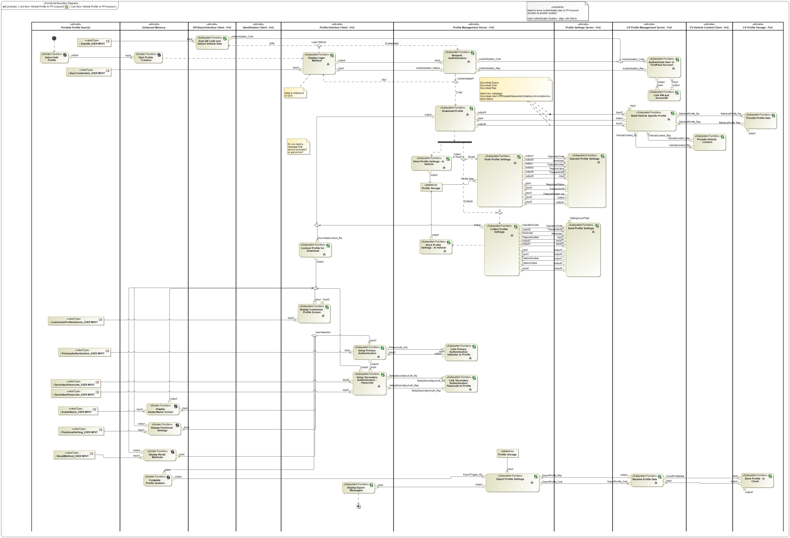

Figure : Activity Diagram of -1287594147.jpg “1 Link New Vehicle Profile w/ FP Account” calling -329216010.jpg “Execute Profile Settings”

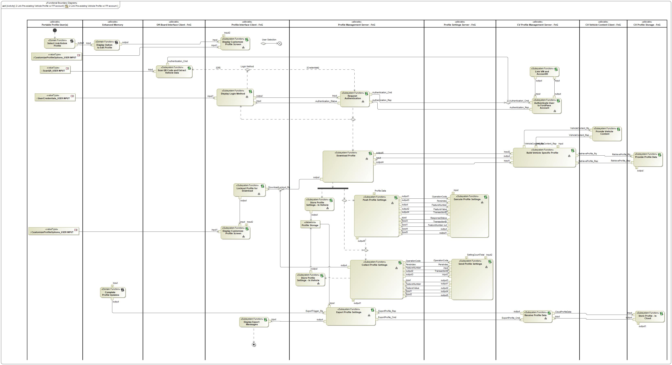

Figure : Activity Diagram of -1287594147.jpg “2 Link Pre-existing Vehicle Profile w/ FP account” calling -329216010.jpg “Execute Profile Settings”

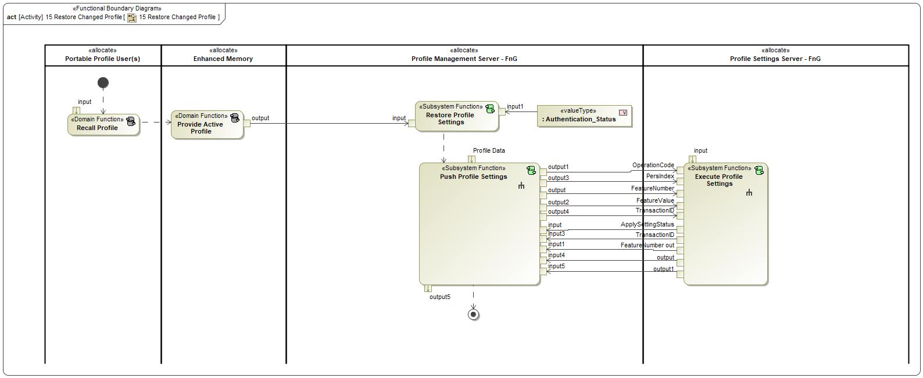

Figure : Activity Diagram of -1287594147.jpg “15 Restore Changed Profile” calling -329216010.jpg “Execute Profile Settings”

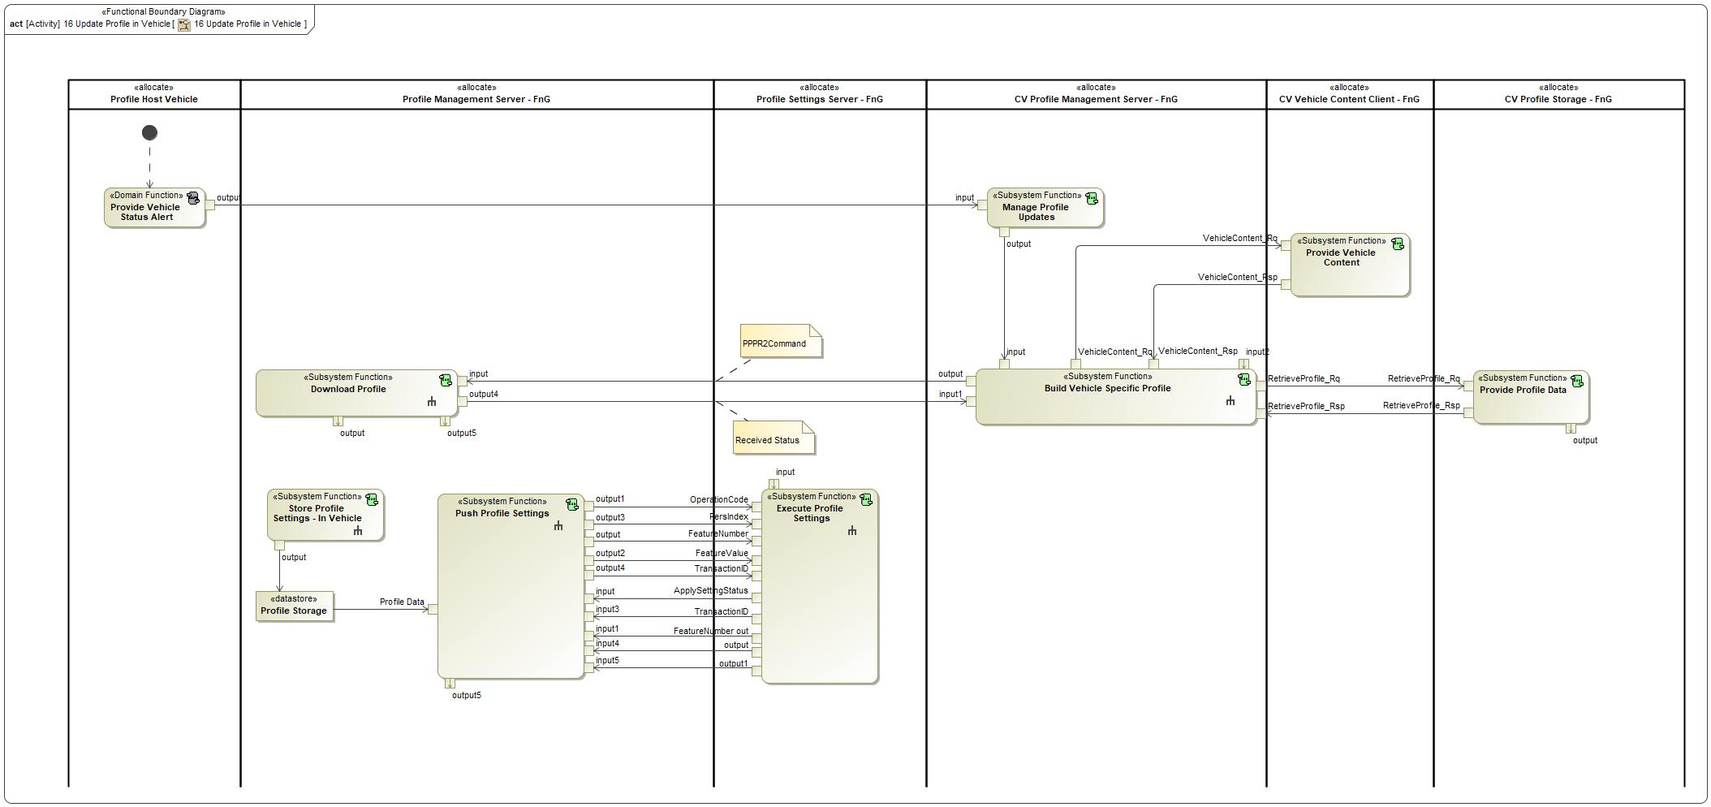

Figure : Activity Diagram of -1287594147.jpg “16 Update Profile in Vehicle” calling -329216010.jpg “Execute Profile Settings”

### Function Interfaces

#### Logical Inputs

|  |  |
| --- | --- |
| **Signal Name** | **Description** |
| input  Type:  -1779037533.jpg ProfileMode | Signal Description:  Determines which feature is utilizing the Personalization Service.  *NOT ALL PROFILE SETTING SERVERS SUPPORT THIS SIGNAL  Received from:   * 1055405719.jpg Push Profile Settings |
| FeatureNumber  Type:  -1779037533.jpg FeatureNumber | Signal Description:  Signal that carries the hexadecimal values assigned to each setting that is stored in the profile.  Received from:   * 1055405719.jpg Push Profile Settings |
| OperationCode  Type:  -1779037533.jpg OperationCode | Signal Description:  Determines which operation the Profile Setting Server is requested to execute. Depending on the operation code, the following signals could contain more or less data.  Received from:   * 1055405719.jpg Push Profile Settings |
| PersIndex  Type:  -1779037533.jpg PersIndex | Signal Description:  Determines the profile number that the Profile Setting Server needs to execute an operation on.  Received from:   * 1055405719.jpg Push Profile Settings |
| TransactionID  Type:  -1779037533.jpg TransactionID | Signal Description:  Unique ID for each request that is valued 1-7. Response echo's back the same transaction ID to ensure a valid request/response transaction.  Received from:   * 1055405719.jpg Push Profile Settings |
| FeatureValue  Type:  -1779037533.jpg FeatureValue | Signal Description:  Carries the setting configuration for a Feature Number. Feature Numbers and Feature Values are always paired together.  Received from:   * 1055405719.jpg Push Profile Settings |

#### Logical Outputs

|  |  |
| --- | --- |
| **Signal Name** | **Description** |
| ResponseStatus  Type:  -1779037533.jpg ResponseStatus | Signal Description:  Determines the status of the response to a PPPSettings_Rq. The ResponseStatus can indicate if an operation is successful, in-progress, failed or if there are errors.  Sent to:   * 1055405719.jpg Push Profile Settings |
| FeatureNumber out  Type:  -1779037533.jpg FeatureNumber | Signal Description:  Signal that carries the hexadecimal values assigned to each setting that is stored in the profile.  Sent to:   * 1055405719.jpg Push Profile Settings |
| TransactionID  Type:  -1779037533.jpg TransactionID | Signal Description:  Unique ID for each request that is valued 1-7. Response echo's back the same transaction ID to ensure a valid request/response transaction.  Sent to:   * 1055405719.jpg Push Profile Settings |
| output1  Type:  -1779037533.jpg SettingCount | Signal Description:  Number of profile settings remaining to be sent to the Profile Management Server.  Sent to:   * 1055405719.jpg Push Profile Settings |
| output  Type:  -1779037533.jpg FeatureValue | Signal Description:  Carries the setting configuration for a Feature Number. Feature Numbers and Feature Values are always paired together.  Sent to:   * 1055405719.jpg Push Profile Settings |

#### Logical Parameters

###LPR_PPPSetTime_00002### LPR_PPPSetTime

Maximum time the Profile Setting Server should take to Set a received FeatureNumber-FeatureValue pair and respond with a status back to the Profile Management Server.

Note: Use the default value

|  |  |  |  |  |  |
| --- | --- | --- | --- | --- | --- |
| **Name** | **Description** | **Units** | **Range** | **Resolution** | **Default** |
| PPPSetTime | Maximum time the Profile Setting Server should take to Set a received FeatureNumber-FeatureValue pair and respond with a status back to the Profile Management Server.  Note: Use the default value | msec | 50-150 | 5 | 75 |

### Function Modeling

#### Use Cases

*Not supported by MagicDraw report generation.*

#### State Charts / Activity Diagrams / Sequence Diagrams / Decision Tables

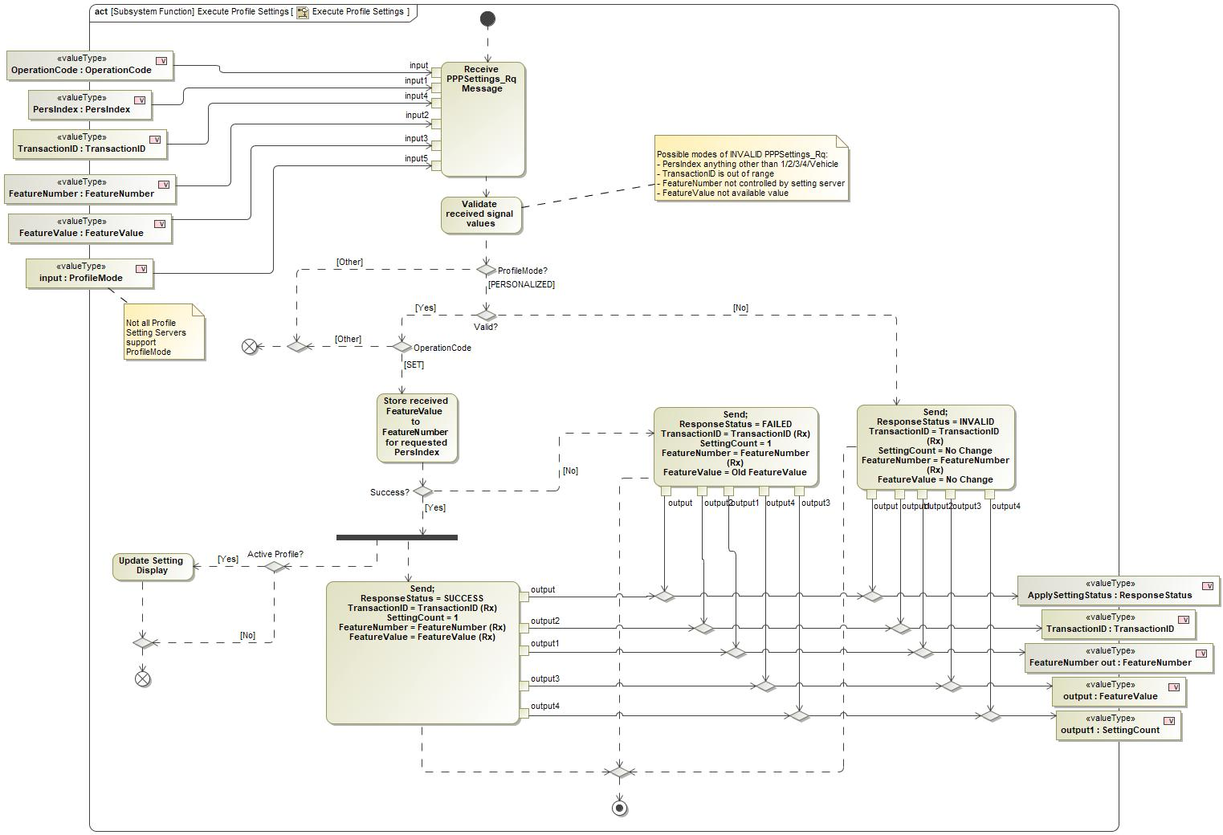

Figure : Execute Profile Settings Activity Diagram

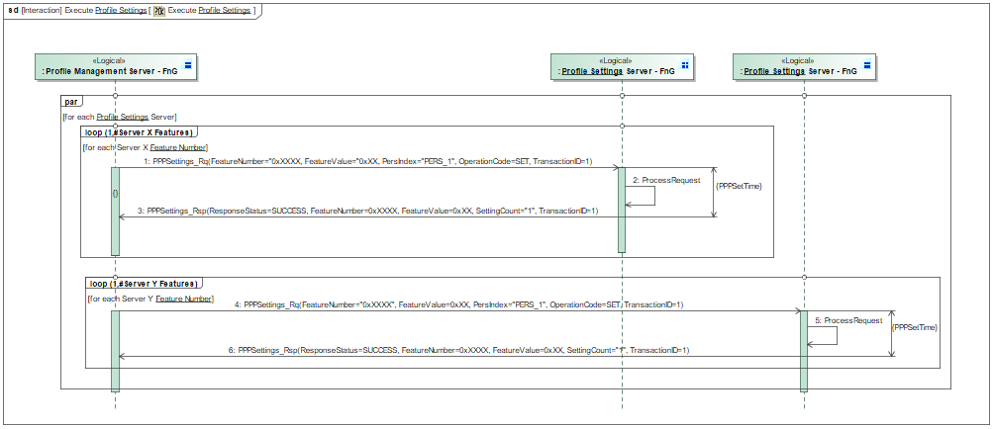

Figure : Execute Profile Settings Sequence Diagram

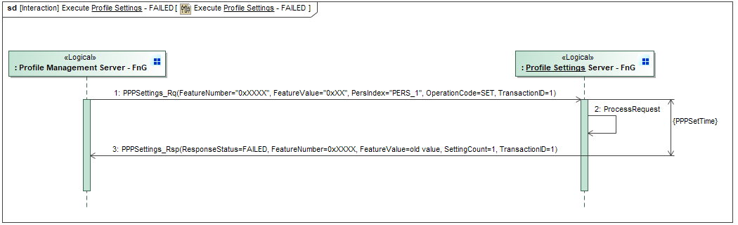

Figure : Execute Profile Settings - FAILED Sequence Diagram

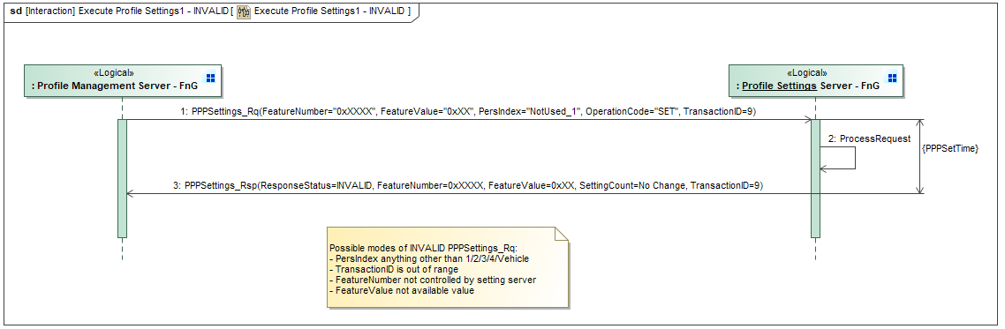

Figure : Execute Profile Settings - INVALID Sequence Diagram

### Function Requirements

#### Functional Requirements

##### Normal Operation

REQ-352214/A Receiving and Processing valid SET operation

When a Profile Setting Server receives a valid PPPSettings_Rq message (see REQ-405863) from the Profile Management Server that contains the signal parameters below, the Profile Setting Server shall immediately apply the received FeatureNumber - FeatureValue pair to the received PersIndex.

- OperationCode = SET

- TransactionID = 0x0 - 0x7

- PersIndex = PERS_1 - PERS_4

- FeatureNumber = 0x0000 - 0xFFFE

- FeatureValue = 0x0000 - 0xFFFF

- ProfileMode = PERSONALIZED*

*Not all Profile Setting Servers support ProfileMode signal (see REQ-405860)

|  |  |  |  |  |  |  |  |
| --- | --- | --- | --- | --- | --- | --- | --- |
| Requirement ID: REQ-352214/A | | | | | | | |
| **Rationale** | PPP requires a central profile storage in the Profile Management Server, thus requiring a means to apply settings from the central storage to each Profile Setting Server. | | | | | | |
| **Acceptance Criteria** | Feature value for the requested Feature number is applied to the correct PersIndex. | | | | | | |
| **Notes** |  | | | | | | |
| **Source** |  | | | | | **Owner** |  |
| **Source Req.** |  | | | | | **V&V Method** |  |
| **Type** |  | | | **Priority** |  | **Status** |  |
| [Req. Template](http://wiki.ford.com/display/RequirementsEngineering/Requirements+Attributes) Version | | 6.0 | End of Requirement | | | | |

REQ-405857/A Display active profile settings after being applied

If the Profile Setting Server has just applied a new profile setting received via the PPPSettings_Rq message from the Profile Management Server to the active profile, the Profile Setting Server shall update their own HMI client to display the updated setting.

|  |  |  |  |  |  |  |  |
| --- | --- | --- | --- | --- | --- | --- | --- |
| Requirement ID: REQ-405857/A | | | | | | | |
| **Rationale** | PPP does not own HMI for all profile settings. | | | | | | |
| **Acceptance Criteria** | HMI Client (SYNC, Cluster, etc.) of the Profile Setting Server is updated after the active profile was synchronized with the connected cloud profile. | | | | | | |
| **Notes** |  | | | | | | |
| **Source** |  | | | | | **Owner** |  |
| **Source Req.** |  | | | | | **V&V Method** |  |
| **Type** |  | | | **Priority** |  | **Status** |  |
| [Req. Template](http://wiki.ford.com/display/RequirementsEngineering/Requirements+Attributes) Version | | 6.0 | End of Requirement | | | | |

REQ-405859/A Memory capability

Each Profile Setting Server shall support enough memory to support at least 5 profile memory positions:

1. Profile 1

2. Profile 2

3. Profile 3

4. Profile 4 (transitional)

5. Vehicle/Guest

**This is not incremental to the Enhanced Memory requirement. PPP and EM use the same memory.**

|  |  |  |  |  |  |  |  |
| --- | --- | --- | --- | --- | --- | --- | --- |
| Requirement ID: REQ-405859/A | | | | | | | |
| **Rationale** | PPP allows for 3 locally saved profiles that can be recalled without needing to push data from the profile management server to the setting servers on every recall. The Profile 4 (transitional) is used to allow more than 3 profiles to be saved to the vehicle and recalled by pushing profile data for every recall. | | | | | | |
| **Acceptance Criteria** | - Memory 1-4 + Guest available for all personalized settings on setting server | | | | | | |
| **Notes** |  | | | | | | |
| **Source** |  | | | | | **Owner** |  |
| **Source Req.** |  | | | | | **V&V Method** |  |
| **Type** |  | | | **Priority** |  | **Status** |  |
| [Req. Template](http://wiki.ford.com/display/RequirementsEngineering/Requirements+Attributes) Version | | 6.0 | End of Requirement | | | | |

REQ-405860/A Profile Setting Servers supporting ProfileMode

If a Profile Setting Server supports other features that utilize the Personalization Service and require additional memory (rejuvenate, stowable steering wheel, etc.), the Profile Setting Server shall support and read the ProfileMode signal in the PPPSettings_Rq. ProfileMode determines which feature is utilizing the Personalization Service for the current request.

|  |  |  |  |  |  |  |  |
| --- | --- | --- | --- | --- | --- | --- | --- |
| Requirement ID: REQ-405860/A | | | | | | | |
| **Rationale** | Not all Profile Setting Servers support multiple personalized features.Those that do need to determine which feature is utilizing the service. | | | | | | |
| **Acceptance Criteria** | ProfileMode signal part of PPPSetting_Rq. Profile Setting Server manipulates the right settings based on the ProfileMode. | | | | | | |
| **Notes** |  | | | | | | |
| **Source** |  | | | | | **Owner** |  |
| **Source Req.** |  | | | | | **V&V Method** |  |
| **Type** |  | | | **Priority** |  | **Status** |  |
| [Req. Template](http://wiki.ford.com/display/RequirementsEngineering/Requirements+Attributes) Version | | 6.0 | End of Requirement | | | | |

REQ-405864/A Sending ResponseStatus = SUCCESS

When the Profile Setting Server successfully applies the feature parameters received in PPPSettings_Rq, the Profile Setting Server shall send the following signal values in the PPPSettings_Rsp:

- ResponseStatus = SUCCESS

- TransactionID = TransactionID(received)

- SettingCount = 1

- FeatureNumber = FeatureNumber(received)

- FeatureValue = FeatureValue(received)

|  |  |  |  |  |  |  |  |
| --- | --- | --- | --- | --- | --- | --- | --- |
| Requirement ID: REQ-405864/A | | | | | | | |
| **Rationale** | Profile Management Server knows not to attempt a retry. | | | | | | |
| **Acceptance Criteria** | - ResponseStatus = SUCCESS sent to Profile Management Server  - Correct Feature Number sent to Profile Management Server  - Correct PersIndex sent to Profile Management Serversent | | | | | | |
| **Notes** |  | | | | | | |
| **Source** |  | | | | | **Owner** |  |
| **Source Req.** |  | | | | | **V&V Method** |  |
| **Type** |  | | | **Priority** |  | **Status** |  |
| [Req. Template](http://wiki.ford.com/display/RequirementsEngineering/Requirements+Attributes) Version | | 6.0 | End of Requirement | | | | |

REQ-421980/A TransactionID for Executing Profile Settings

When the Profile Setting Server receives PPPSettings_Rq with a TransactionID = 1-7, the Profile Setting Server shall send PPPSettings_Rsp with the same Transaction ID the was received in the PPPSettings_Rq.

|  |  |  |  |  |  |  |  |
| --- | --- | --- | --- | --- | --- | --- | --- |
| Requirement ID: REQ-421980/A | | | | | | | |
| **Rationale** | Correlates the request and the response. | | | | | | |
| **Acceptance Criteria** | Same transaction ID that was received is sent back to the Profile Management Server in the response message. | | | | | | |
| **Notes** |  | | | | | | |
| **Source** |  | | | | | **Owner** |  |
| **Source Req.** |  | | | | | **V&V Method** |  |
| **Type** |  | | | **Priority** |  | **Status** |  |
| [Req. Template](http://wiki.ford.com/display/RequirementsEngineering/Requirements+Attributes) Version | | 6.0 | End of Requirement | | | | |

##### Error Handling

REQ-353147/A Setting Server Unable to Apply Setting (ResponseStatus = FAILED)

If a Profile Setting Server is unable to apply a Feature Value for a Feature Number that is sent from the Profile Management Server, the Profile Setting Server shall retain the previous Feature Value for the requested Feature Number and send the following signal values in the PPPSettings_Rsp:

- ResponseStatus = FAILED

- TransactionID = TransactionID(received)

- SettingCount = 1

- FeatureNumber = FeatureNumber(received)

- FeatureValue = Old FeatureValue

|  |  |  |  |  |  |  |  |
| --- | --- | --- | --- | --- | --- | --- | --- |
| Requirement ID: REQ-353147/A | | | | | | | |
| **Rationale** | Need to tell Profile Management Server if the request has FAILED so that the issue can be understood and fixed. | | | | | | |
| **Acceptance Criteria** | - ResponseStatus = FAILED  - Same feature number that was received is sent back to Profile Management Server.  - Old feature value send to the Profile Management Server | | | | | | |
| **Notes** |  | | | | | | |
| **Source** |  | | | | | **Owner** |  |
| **Source Req.** |  | | | | | **V&V Method** |  |
| **Type** |  | | | **Priority** |  | **Status** |  |
| [Req. Template](http://wiki.ford.com/display/RequirementsEngineering/Requirements+Attributes) Version | | 6.0 | End of Requirement | | | | |

REQ-405856/A PPPSettings_Rsp signal values for ResponseStatus = INVALID

When the Profile Setting Server is sending ResponseStatus = INVALID, the Profile Setting Server shall populate the remaining PPPSettings_Rsp signals as follows:

- ResponseStatus = INVALID

- TransactionID = TransactionID(received)

- SettingCount = 1

- FeatureNumber = FeatureNumber(received)

- FeatureValue = Don't Care

|  |  |  |  |  |  |  |  |
| --- | --- | --- | --- | --- | --- | --- | --- |
| Requirement ID: REQ-405856/A | | | | | | | |
| **Rationale** | Need to tell Profile Management Server of an INVALID message so that the issue can be understood and fixed. | | | | | | |
| **Acceptance Criteria** | -PPPSettings_Rsp populated with the correct values for an INVALID response. | | | | | | |
| **Notes** |  | | | | | | |
| **Source** |  | | | | | **Owner** |  |
| **Source Req.** |  | | | | | **V&V Method** |  |
| **Type** |  | | | **Priority** |  | **Status** |  |
| [Req. Template](http://wiki.ford.com/display/RequirementsEngineering/Requirements+Attributes) Version | | 6.0 | End of Requirement | | | | |

REQ-405858/A Priority of applying profile settings

If a Profile Setting Server receives a request to change a profile setting from the PPPSettings_Rq signal and the setting's HMI Client simultaneously, the Profile Setting Server shall retain the setting value received from HMI Client.

|  |  |  |  |  |  |  |  |
| --- | --- | --- | --- | --- | --- | --- | --- |
| Requirement ID: REQ-405858/A | | | | | | | |
| **Rationale** | Priority should be given to the customer actions. | | | | | | |
| **Acceptance Criteria** | Setting changed from the HMI Client is the active setting in the vehicle. | | | | | | |
| **Notes** |  | | | | | | |
| **Source** |  | | | | | **Owner** |  |
| **Source Req.** |  | | | | | **V&V Method** |  |
| **Type** |  | | | **Priority** |  | **Status** |  |
| [Req. Template](http://wiki.ford.com/display/RequirementsEngineering/Requirements+Attributes) Version | | 6.0 | End of Requirement | | | | |

REQ-405863/A When to send ResponseStatus = INVALID

The Profile Setting Servers shall send a PPPSettings_Rsp with ResponseStatus = INVALID when any of the following occur:

- PersIndex equals anything other than PERS_1, PERS_2, PERS_3, PERS_4, VEHICLE

- TransactionID out of range (0x0 - 0x7)

- FeatureNumber not controlled by Profile Setting Server

- FeatureValue not available value

|  |  |  |  |  |  |  |  |
| --- | --- | --- | --- | --- | --- | --- | --- |
| Requirement ID: REQ-405863/A | | | | | | | |
| **Rationale** | So that Profile Management Server can determine the reason of failure and attempt a retry. | | | | | | |
| **Acceptance Criteria** | - ResponseStatus = INVALID sent to Profile Management Server  - Correct Feature Number sent to Profile Management Server  - Correct PersIndex sent to Profile Management Server | | | | | | |
| **Notes** |  | | | | | | |
| **Source** |  | | | | | **Owner** |  |
| **Source Req.** |  | | | | | **V&V Method** |  |
| **Type** |  | | | **Priority** |  | **Status** |  |
| [Req. Template](http://wiki.ford.com/display/RequirementsEngineering/Requirements+Attributes) Version | | 6.0 | End of Requirement | | | | |

#### Non-Functional Requirements

REQ-405861/A Execute Profile Settings Performance

When a Profile Setting Server receives a SET command from the Profile Management Server, the Profile Setting Server shall be able to save the settings and then send the PPPSettings_Rsp back to the Profile Management Server within PPPSetTime.

|  |  |  |  |  |  |
| --- | --- | --- | --- | --- | --- |
| **Name** | **Description** | **Units** | **Range** | **Resolution** | **Default** |
| PPPSetTime | Maximum time the Profile Setting Server should take to Set a received FeatureNumber-FeatureValue pair and respond with a status back to the Profile Management Server.  Note: Use the default value | msec | 50 - 150 | 5 | 75 |

|  |  |  |  |  |  |  |  |
| --- | --- | --- | --- | --- | --- | --- | --- |
| Requirement ID: REQ-405861/A | | | | | | | |
| **Rationale** | Do not want to build latency while setting multiple settings on a single Profile Setting Server. | | | | | | |
| **Acceptance Criteria** | - PPPSettings_Rsp sent within PPPSetTime of receiving PPPSettings_Rq | | | | | | |
| **Notes** |  | | | | | | |
| **Source** |  | | | | | **Owner** |  |
| **Source Req.** |  | | | | | **V&V Method** |  |
| **Type** |  | | | **Priority** |  | **Status** |  |
| [Req. Template](http://wiki.ford.com/display/RequirementsEngineering/Requirements+Attributes) Version | | 6.0 | End of Requirement | | | | |

#### Functional Safety Requirements

No Functional Safety Requirements specified.

##### ASIL Decomposition of Functional Safety Requirements

No Functional Safety Requirements with ASIL Decompositions specified.

#### Other Requirements

##### Design Requirements

No Design Requirements specified.

## -329216010.jpg Send Changed Profile Setting

### Function Overview

#### Description

Function is allocated to:

* -231321925.jpg Profile Settings Server - FnG <<Logical>>

A function of the Profile Setting Servers that sends a change notification to the Profile Management Server when a change is made to a profile setting of an active profile. The notification does not determine which profile setting was changed, just that a change occurred and the Profile Management Server must query the active profile to refresh the local copy.

#### Variants

*Not supported by MagicDraw report generation.*

#### Input Requirements

*Not supported by MagicDraw report generation.*

#### Assumptions

No assumptions specified for this function.

#### References

##### Ford Documents

List here all Ford internal documents, which are directly related to the feature.

| **Reference** | **Title** | **Doc. ID** | **Revision** |
| --- | --- | --- | --- |
|  | Enhanced Memory Feature Specification | VDOC041625 | V3.1 |

Table 5: Ford internal Documents *(not specified in model)*

##### External Documents and Publications

The list of external documents could include books, reports and online sources.

| **Reference** | **Document / Publication** |
| --- | --- |
|  |  |

Table 6: External documents and publications *(not specified in model)*

#### Glossary

See Appendix for Definitions and Abbreviations.

### Function Scope

The -329216010.jpg **– “Send Changed Profile Setting”** function is called by the following functions:

* -1287594147.jpg – “7 Synchronize Profile with the Cloud”

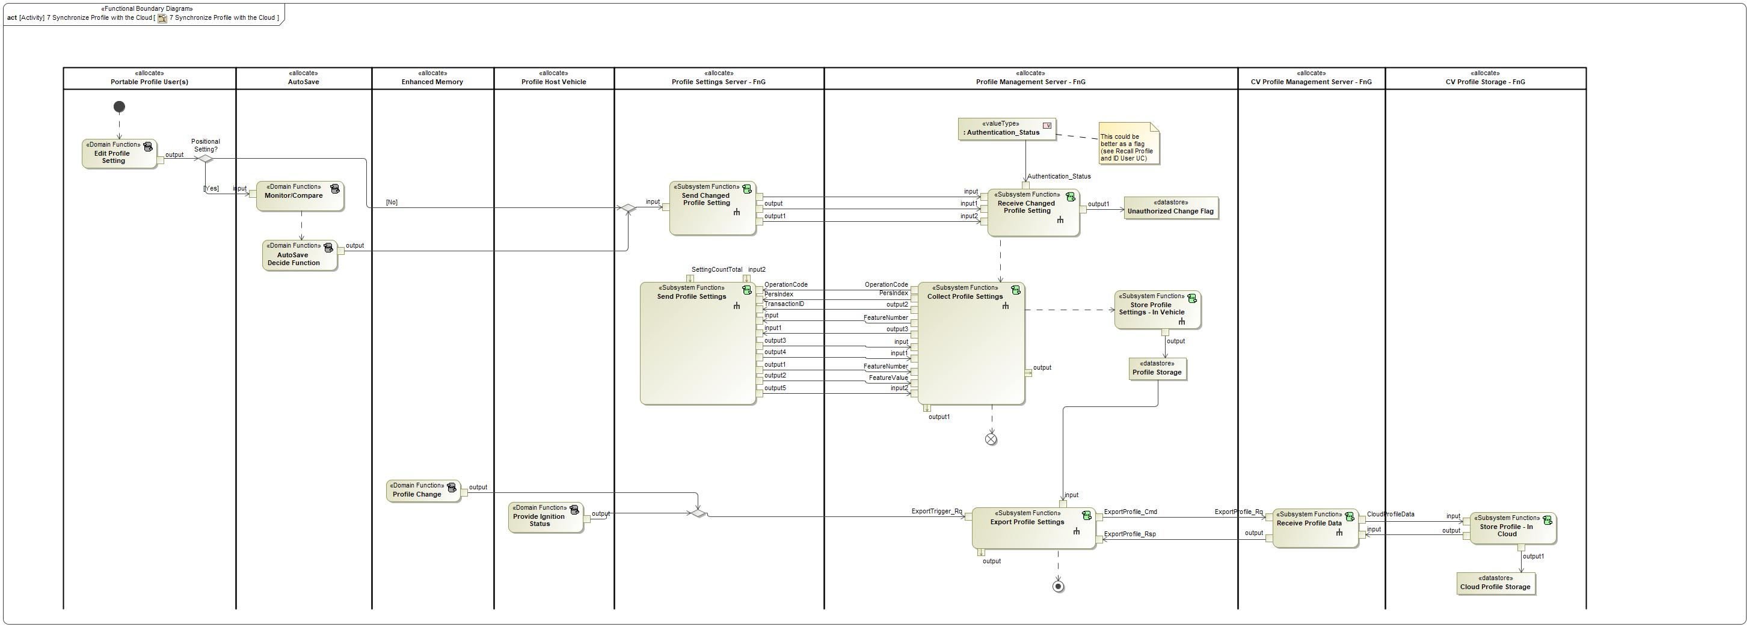

Figure : Activity Diagram of -1287594147.jpg “7 Synchronize Profile with the Cloud” calling -329216010.jpg “Send Changed Profile Setting”

### Function Interfaces

#### Logical Inputs

|  |  |
| --- | --- |
| **Signal Name** | **Description** |
| input  Type:  -122611741.jpg SettingChanged | Received from:   * 415518496.jpg Edit Profile Setting * 415518496.jpg AutoSave Decide Function |

#### Logical Outputs

|  |  |
| --- | --- |
| **Signal Name** | **Description** |
| output1  Type:  -1779037533.jpg PersIndex | Signal Description:  Determines the profile number that the Profile Setting Server needs to execute an operation on.  Sent to:   * -1821753104.jpg Receive Changed Profile Setting |
| output  Type:  -1779037533.jpg ProfileMode | Signal Description:  Determines which feature is utilizing the Personalization Service.  *NOT ALL PROFILE SETTING SERVERS SUPPORT THIS SIGNAL  Sent to:   * -1821753104.jpg Receive Changed Profile Setting |
| Type:  -122611741.jpg Change_Notification | Signal Description:  Notifies the Profile Management Server that a change has been made to the active profile.  Sent to:   * -1821753104.jpg Receive Changed Profile Setting |

#### Logical Parameters

*Not supported by MagicDraw report generation.*

### Function Modeling

#### Use Cases

*Not supported by MagicDraw report generation.*

#### State Charts / Activity Diagrams / Sequence Diagrams / Decision Tables

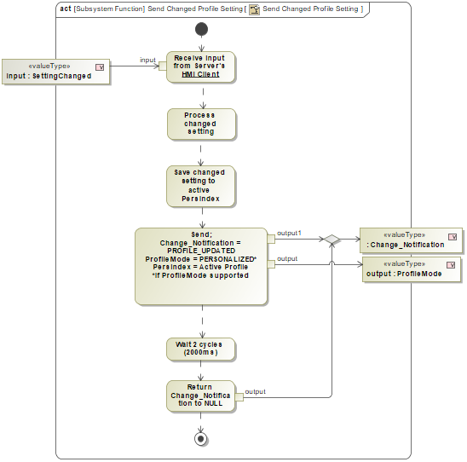

Figure : Send Changed Profile Setting

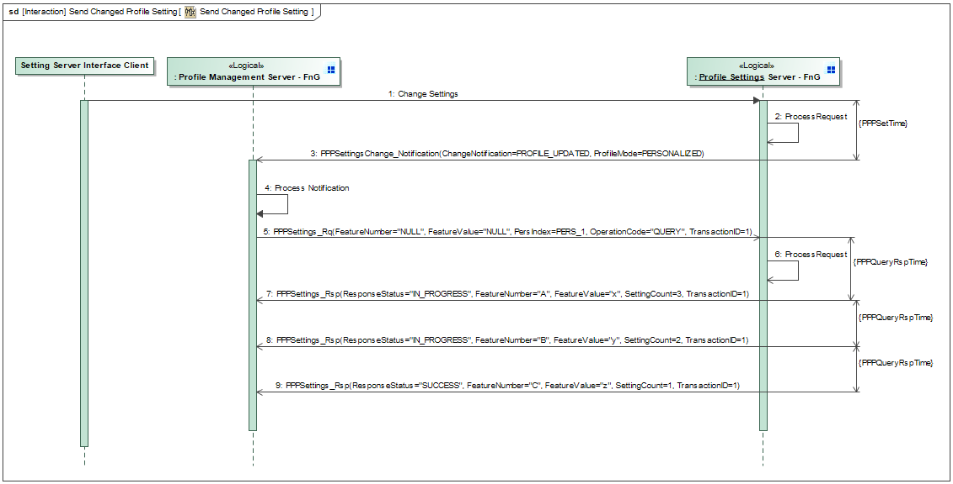

Figure : Send Changed Profile Setting Sequence Diagram

### Function Requirements

#### Functional Requirements

##### Normal Operation

REQ-421983/A Send Change_Notification to Profile Management Server

When a customer makes a change to a profile setting and the setting is saved to the active profile, the Profile Setting Server that controls the changed setting shall send PPPSettingsChange_Notification message with the following signal parameters to the Profile Management Server:

- Change_Notification = PROFILE_UPDATED

- ProfileMode = PERSONALIZED*

*Not all Profile Setting Servers support ProfileMode signal (see REQ-405860)

|  |  |  |  |  |  |  |  |
| --- | --- | --- | --- | --- | --- | --- | --- |
| Requirement ID: REQ-421983/A | | | | | | | |
| **Rationale** | Notify the Profile Management Server that a profile setting has changed. | | | | | | |
| **Acceptance Criteria** | - Change_Notification = PROFILE_UPDATED  - ProfileMode = PERSONALIZED* if supported by profile setting server | | | | | | |
| **Notes** |  | | | | | | |
| **Source** |  | | | | | **Owner** |  |
| **Source Req.** |  | | | | | **V&V Method** |  |
| **Type** |  | | | **Priority** |  | **Status** |  |
| [Req. Template](http://wiki.ford.com/display/RequirementsEngineering/Requirements+Attributes) Version | | 6.0 | End of Requirement | | | | |

REQ-421985/A Set Change_Notification to NULL after a change

After the Profile Setting Server sends Change_Notification = PROFILE_UPDATED for a changed profile setting, the Profile Setting Server shall return the Change_Notification to NULL after 2 cycles (2000ms).

|  |  |  |  |  |  |  |  |
| --- | --- | --- | --- | --- | --- | --- | --- |
| Requirement ID: REQ-421985/A | | | | | | | |
| **Rationale** | Only want to notify on a change, signal needs to be nullified to allow for new changes. | | | | | | |
| **Acceptance Criteria** | Change_Notification nullified after after 2000 ms. | | | | | | |
| **Notes** |  | | | | | | |
| **Source** |  | | | | | **Owner** |  |
| **Source Req.** |  | | | | | **V&V Method** |  |
| **Type** |  | | | **Priority** |  | **Status** |  |
| [Req. Template](http://wiki.ford.com/display/RequirementsEngineering/Requirements+Attributes) Version | | 6.0 | End of Requirement | | | | |

##### Error Handling

No Error Handling Requirements specified.

#### Non-Functional Requirements

REQ-421984/A Send Change_Notification Performance Requirement

When a Profile Setting Server changes an active profile setting due to user input, the Profile Setting Server shall be able to save the settings to the active profile memory and then send the Change_Notification = PROFILE_UPDATED within PPPSetTime.

|  |  |  |  |  |  |
| --- | --- | --- | --- | --- | --- |
| **Name** | **Description** | **Units** | **Range** | **Resolution** | **Default** |
| PPPSetTime | Maximum time the Profile Setting Server should take to Set a received FeatureNumber-FeatureValue pair and respond with a status back to the Profile Management Server.  Note: Use the default value | msec | 50-150 | 5 | 75 |

|  |  |  |  |  |  |  |  |
| --- | --- | --- | --- | --- | --- | --- | --- |
| Requirement ID: REQ-421984/A | | | | | | | |
| **Rationale** | Do not want to build latency when saving changed settings. | | | | | | |
| **Acceptance Criteria** | Change_Notification = PROFILE_UPDATED within PPPSetTime. | | | | | | |
| **Notes** |  | | | | | | |
| **Source** |  | | | | | **Owner** |  |
| **Source Req.** |  | | | | | **V&V Method** |  |
| **Type** |  | | | **Priority** |  | **Status** |  |
| [Req. Template](http://wiki.ford.com/display/RequirementsEngineering/Requirements+Attributes) Version | | 6.0 | End of Requirement | | | | |

#### Functional Safety Requirements

No Functional Safety Requirements specified.

##### ASIL Decomposition of Functional Safety Requirements

No Functional Safety Requirements with ASIL Decompositions specified.

#### Other Requirements

##### Design Requirements

No Design Requirements specified.

## -329216010.jpg Send Profile Settings

### Function Overview

#### Description

Function is allocated to:

* -231321925.jpg Profile Settings Server - FnG <<Logical>>

This function sends profile data associated to a user profile that is stored on the Profile Setting Server to the Profile Management Server when the PPPSettings_Rq with OperationCode = QUERY is received. The received query operation can be for a specific Feature Number or can be a batch query (FeatureNumber = NULL in PPPSettings_Rq) of all profile data associated to a profile.

#### Variants

*Not supported by MagicDraw report generation.*

#### Input Requirements

*Not supported by MagicDraw report generation.*

#### Assumptions

No assumptions specified for this function.

#### References

##### Ford Documents

List here all Ford internal documents, which are directly related to the feature.

| **Reference** | **Title** | **Doc. ID** | **Revision** |
| --- | --- | --- | --- |
|  | Enhanced Memory Feature Specification | VDOC041625 | V3.1 |

Table 7: Ford internal Documents *(not specified in model)*

##### External Documents and Publications

The list of external documents could include books, reports and online sources.

| **Reference** | **Document / Publication** |
| --- | --- |
|  |  |

Table 8: External documents and publications *(not specified in model)*

#### Glossary

See Appendix for Definitions and Abbreviations.

### Function Scope

The -329216010.jpg **– “Send Profile Settings”** function is called by the following functions:

* -1287594147.jpg – “1 Link New Vehicle Profile w/ FP Account”
* -1287594147.jpg – “2 Link Pre-existing Vehicle Profile w/ FP account”
* -1287594147.jpg – “7 Synchronize Profile with the Cloud”



Figure : Activity Diagram of -1287594147.jpg “1 Link New Vehicle Profile w/ FP Account” calling -329216010.jpg “Send Profile Settings”



Figure : Activity Diagram of -1287594147.jpg “2 Link Pre-existing Vehicle Profile w/ FP account” calling -329216010.jpg “Send Profile Settings”



Figure : Activity Diagram of -1287594147.jpg “7 Synchronize Profile with the Cloud” calling -329216010.jpg “Send Profile Settings”

### Function Interfaces

#### Logical Inputs

|  |  |
| --- | --- |
| **Signal Name** | **Description** |
| input2  Type:  -1779037533.jpg ProfileMode | Signal Description:  Determines which feature is utilizing the Personalization Service.  *NOT ALL PROFILE SETTING SERVERS SUPPORT THIS SIGNAL  Received from:   * -1821753104.jpg Collect Profile Settings |
| input  Type:  -1779037533.jpg FeatureNumber | Signal Description:  Signal that carries the hexadecimal values assigned to each setting that is stored in the profile.  Received from:   * -1821753104.jpg Collect Profile Settings |
| input1  Type:  -1779037533.jpg FeatureValue | Signal Description:  Carries the setting configuration for a Feature Number. Feature Numbers and Feature Values are always paired together.  Received from:   * -1821753104.jpg Collect Profile Settings |
| TransactionID  Type:  -1779037533.jpg TransactionID | Signal Description:  Unique ID for each request that is valued 1-7. Response echo's back the same transaction ID to ensure a valid request/response transaction.  Received from:   * -1821753104.jpg Collect Profile Settings |
| OperationCode  Type:  -1779037533.jpg OperationCode | Signal Description:  Determines which operation the Profile Setting Server is requested to execute. Depending on the operation code, the following signals could contain more or less data.  Received from:   * -1821753104.jpg Collect Profile Settings |
| PersIndex  Type:  -1779037533.jpg PersIndex | Signal Description:  Determines the profile number that the Profile Setting Server needs to execute an operation on.  Received from:   * -1821753104.jpg Collect Profile Settings |

#### Logical Outputs

|  |  |
| --- | --- |
| **Signal Name** | **Description** |
| output4  Type:  -1779037533.jpg TransactionID | Signal Description:  Unique ID for each request that is valued 1-7. Response echo's back the same transaction ID to ensure a valid request/response transaction.  Sent to:   * -1821753104.jpg Collect Profile Settings |
| output1  Type:  -1779037533.jpg FeatureNumber | Signal Description:  Signal that carries the hexadecimal values assigned to each setting that is stored in the profile.  Sent to:   * -1821753104.jpg Collect Profile Settings |
| output2  Type:  -1779037533.jpg FeatureValue | Signal Description:  Carries the setting configuration for a Feature Number. Feature Numbers and Feature Values are always paired together.  Sent to:   * -1821753104.jpg Collect Profile Settings |
| output3  Type:  -1779037533.jpg ResponseStatus | Signal Description:  Determines the status of the response to a PPPSettings_Rq. The ResponseStatus can indicate if an operation is successful, in-progress, failed or if there are errors.  Sent to:   * -1821753104.jpg Collect Profile Settings |
| output5  Type:  -1779037533.jpg SettingCount | Signal Description:  Number of profile settings remaining to be sent to the Profile Management Server.  Sent to:   * -1821753104.jpg Collect Profile Settings |

#### Logical Parameters

*Not supported by MagicDraw report generation.*

### Function Modeling

#### Use Cases

*Not supported by MagicDraw report generation.*

#### State Charts / Activity Diagrams / Sequence Diagrams / Decision Tables

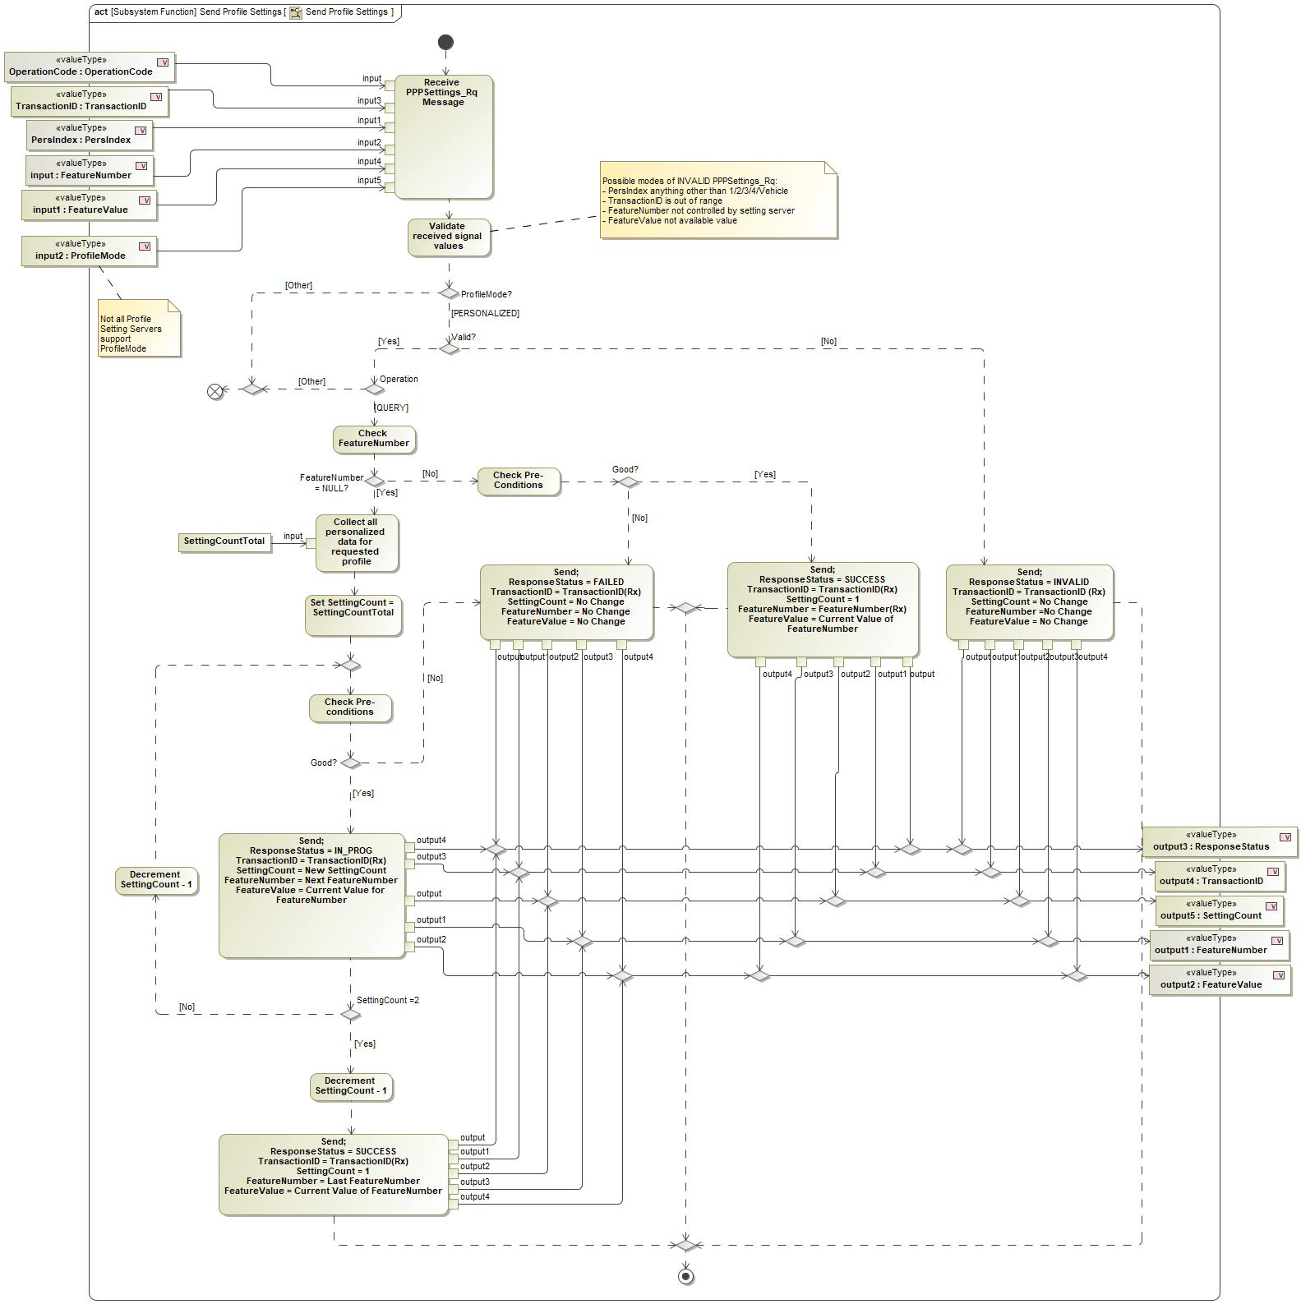

Figure : Send Profile Settings

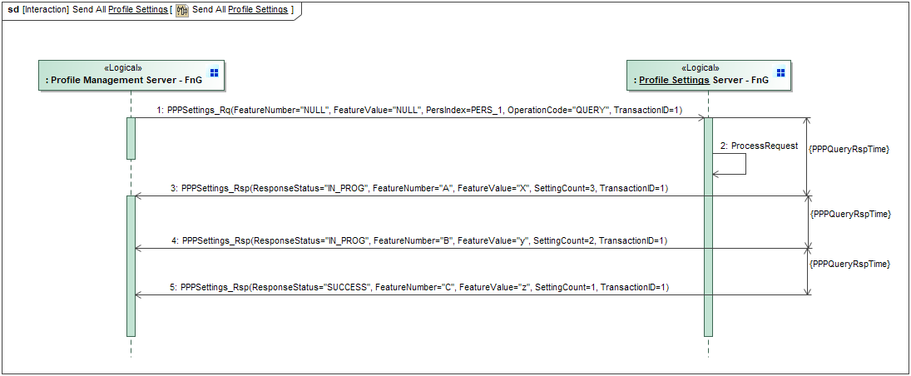

Figure : Send All Profile Settings Sequence Diagram

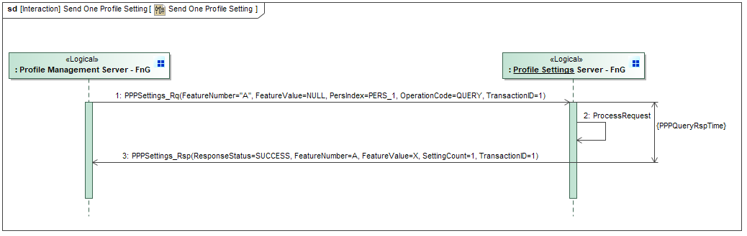

Figure : Send One Profile Setting Sequence Diagram

### Function Requirements

#### Functional Requirements

##### Normal Operation

REQ-352238/A Response to a Profile Management Server QUERY ALL

When the Profile Setting Server receives a QUERY ALL settings request (OperationCode = QUERY and FeatureNumber = NULL (0xFFFF)) via the PPPSetting_Rq from the Profile Management Server, the Profile Setting Server shall send the PPPSetting_Rsp message with the following signal parameters for each FeatureNumber and FeatureValue combination stored by the Profile Setting Server.

- ResponseStatus = IN_PROG until SettingCount = 1, then ResponseStatus = SUCCESS

-TransactionID = TransactionID(received)

- SettingCount = SettingCountTotal for first response, and then decrements by 1 for each subsequent response until SettingCount = 1

- FeatureNumber = next parameter of the Profile Setting Server

- FeatureValue = FeatureValue of FeatureNumber

|  |  |  |  |  |  |  |  |
| --- | --- | --- | --- | --- | --- | --- | --- |
| Requirement ID: REQ-352238/A | | | | | | | |
| **Rationale** | Profile Management Server needs to know the status of the request, how many settings are expected and the feature number - feature value pair for each setting. | | | | | | |
| **Acceptance Criteria** | - IN_PROG response until the final setting  - SettingCount decrements after each consecutive message  - Feature number and feature value change for each consecutive message  - All profile settings controlled by the Profile Setting Server sent to the Proflie Management Server. | | | | | | |
| **Notes** |  | | | | | | |
| **Source** |  | | | | | **Owner** |  |
| **Source Req.** |  | | | | | **V&V Method** |  |
| **Type** |  | | | **Priority** |  | **Status** |  |
| [Req. Template](http://wiki.ford.com/display/RequirementsEngineering/Requirements+Attributes) Version | | 6.0 | End of Requirement | | | | |

REQ-352239/A Interruption from setting server HMI during QUERY response

If the Profile Setting Server receives a request from setting server HMI Client during a QUERY response, the Profile Setting Server shall pause QUERY response, process the HMI Client request and then resume the QUERY response with the updated Feature Value based on the processed HMI Client request.

|  |  |  |  |  |  |  |  |
| --- | --- | --- | --- | --- | --- | --- | --- |
| Requirement ID: REQ-352239/A | | | | | | | |
| **Rationale** | Priority is to process user input requests first. | | | | | | |
| **Acceptance Criteria** | Profile Setting Server processes HMI request and then continues QUERY responses. | | | | | | |
| **Notes** |  | | | | | | |
| **Source** |  | | | | | **Owner** |  |
| **Source Req.** |  | | | | | **V&V Method** |  |
| **Type** |  | | | **Priority** |  | **Status** |  |
| [Req. Template](http://wiki.ford.com/display/RequirementsEngineering/Requirements+Attributes) Version | | 6.0 | End of Requirement | | | | |

REQ-421981/A Response to QUERY ONE setting

When the Profile Setting Server receives a QUERY ONE setting request (OperationCode = QUERY and FeatureNumber = non-NULL) via the PPPSetting_Rq from the Profile Management Server, the Profile Setting Server shall send the PPPSetting_Rsp message with the following signal parameters:

- ResponseStatus = SUCCESS

-TransactionID = TransactionID(received)

- SettingCount = 1

- FeatureNumber = FeatureNumber(received)

- FeatureValue = FeatureValue of FeatureNumber

|  |  |  |  |  |  |  |  |
| --- | --- | --- | --- | --- | --- | --- | --- |
| Requirement ID: REQ-421981/A | | | | | | | |
| **Rationale** | Allow for the possibilty for Profile Management Server to query a single setting. | | | | | | |
| **Acceptance Criteria** | Profile Setting Server only sends the requested feature number - feature value pair. | | | | | | |
| **Notes** |  | | | | | | |
| **Source** |  | | | | | **Owner** |  |
| **Source Req.** |  | | | | | **V&V Method** |  |
| **Type** |  | | | **Priority** |  | **Status** |  |
| [Req. Template](http://wiki.ford.com/display/RequirementsEngineering/Requirements+Attributes) Version | | 6.0 | End of Requirement | | | | |

REQ-421982/A SettingCountTotal parameter

Each Profile Setting Server shall maintain a parameter called SettingCountTotal, which stores the total number of personalized settings stored in the Profile Setting Server.

|  |  |  |  |  |  |  |  |
| --- | --- | --- | --- | --- | --- | --- | --- |
| Requirement ID: REQ-421982/A | | | | | | | |
| **Rationale** | On a QUERY ALL operation, profile setting server needs to know how many consecutive feature numbers to send to the Profile Management Server. This helps determine that the transaction is over when SettingCount = 1. | | | | | | |
| **Acceptance Criteria** |  | | | | | | |
| **Notes** |  | | | | | | |
| **Source** |  | | | | | **Owner** |  |
| **Source Req.** |  | | | | | **V&V Method** |  |
| **Type** |  | | | **Priority** |  | **Status** |  |
| [Req. Template](http://wiki.ford.com/display/RequirementsEngineering/Requirements+Attributes) Version | | 6.0 | End of Requirement | | | | |

##### Error Handling

REQ-352217/A Unable to send PPPSetting_Rsp after QUERY request

If the Profile Setting Server is unable to send FeatureNumber and FeatureValue pair after a QUERY command due to unmet pre-conditions, the Profile Setting Server shall send PPPSettings_Rsp with the following signal values:

- ResponseStatus = FAILED

- TransactionID = TransactionID(Rx)

- SettingCount = No Change

- FeatureNumber = No Change

- FeatureValue = No Change

|  |  |  |  |  |  |  |  |
| --- | --- | --- | --- | --- | --- | --- | --- |
| Requirement ID: REQ-352217/A | | | | | | | |
| **Rationale** | Profile Management Server will be able to act upon error codes and attempt a retry strategy. | | | | | | |
| **Acceptance Criteria** |  | | | | | | |
| **Notes** |  | | | | | | |
| **Source** |  | | | | | **Owner** |  |
| **Source Req.** |  | | | | | **V&V Method** |  |
| **Type** |  | | | **Priority** |  | **Status** |  |
| [Req. Template](http://wiki.ford.com/display/RequirementsEngineering/Requirements+Attributes) Version | | 6.0 | End of Requirement | | | | |

#### Non-Functional Requirements

REQ-405867/A Performance to send PPPSetting_Rsp on a QUERY ALL request

When a Profile Setting Server receives a QUERY ALL request (OperationCode = QUERY, FeatureNumber = NULL) from the Profile Management Server, the Profile Setting Server shall send each FeatureNumber-FeatureValue pair at PPPQueryRspTime intervals via the PPPSetting_Rsp.

|  |  |  |  |  |  |
| --- | --- | --- | --- | --- | --- |
| **Name** | **Description** | **Units** | **Range** | **Resolution** | **Default** |
| PPPQueryRspTime | Maximum time the Profile Setting Server should take to send a new FeatureNumber – FeatureValue pair to the Profile Management Server after a QUERY request  Note: Use the default value | msec | 50-150 | 5 | 100 |

|  |  |  |  |  |  |  |  |
| --- | --- | --- | --- | --- | --- | --- | --- |
| Requirement ID: REQ-405867/A | | | | | | | |
| **Rationale** | Do not want to build latency while collecting profile settings. | | | | | | |
| **Acceptance Criteria** | Each profile setting sent within 100 ms intervals. | | | | | | |
| **Notes** |  | | | | | | |
| **Source** |  | | | | | **Owner** |  |
| **Source Req.** |  | | | | | **V&V Method** |  |
| **Type** |  | | | **Priority** |  | **Status** |  |
| [Req. Template](http://wiki.ford.com/display/RequirementsEngineering/Requirements+Attributes) Version | | 6.0 | End of Requirement | | | | |

#### Functional Safety Requirements

No Functional Safety Requirements specified.

##### ASIL Decomposition of Functional Safety Requirements

No Functional Safety Requirements with ASIL Decompositions specified.

#### Other Requirements

##### Design Requirements

No Design Requirements specified.

## Activate Passenger Profile

### Function Overview

#### Description

**#Hint:** Some descriptive text to explain the purpose and functionality of the function.

Function is allocated to:

* 1716959969.jpg Front Passenger Profiles <<Feature>>
* -960180345.jpg Profile Settings Server - FnG <<Logical>>

Action taken by the Profile Setting Server when a Passenger Profile Activation request has been received.

#### Variants

**#Classification**: Mandatory (State “Not applicable”, if not used)

**#Hint:** If different variants of the same function are specified in this section, list those variants in the table below.

Variants on Function level could be driven technology or feature content. Example: There could be a “Low Content” and a “High Content” variant of some exterior lighting function. The Low Content variant applies for Conventional Headlight technology, the High Content variant applies for LED and Xenon technology. In this case we call the different technologies the Variant Options (for the time being you could think of them as Logical Parameters) which the Variant depends on. The optional column “Variant condition” allows to express the dependency of a Variant based on Variant Options/Logical Parameters.

If requirements/signals are not applicable for all variants/variant options, those requirements should state explicitly, which function variant/variant option they apply to.

**#Link:** [RE Wiki – Variant Management](http://wiki.ford.com/display/RequirementsEngineering/Variant+Management).

*Not supported by MagicDraw report generation.*

#### Input Requirements

**#Classification**: Mandatory (State “Not applicable”, if not used)

**#Hint:** List any input requirements here (legal, Trustmark), which need to be taken into account, beyond what is specified in the corresponding Feature Documents.

*Not supported by MagicDraw report generation.*

#### Assumptions

**#Classification**: Mandatory (State “Not applicable”, if not used)

**#Hint:** A list of known assumptions concerning the effects of the function’s behavior on other functions or elements (i.e., dependencies) as well as assumptions on the behavior expected by the function (e.g. known limitations). During the course of the development most of those assumptions are typically either converted into actual requirements or discarded at some point – such that this chapter remains mostly empty.

No assumptions specified for this function.

#### References

##### Ford Documents

List here all Ford internal documents, which are directly related to the feature.

| **Reference** | **Title** | **Doc. ID** | **Revision** |
| --- | --- | --- | --- |
|  |  |  |  |

Table 5: Ford internal Documents *(not specified in model)*

##### External Documents and Publications

The list of external documents could include books, reports and online sources.

**#Hint:** You may refer to [IEEE Citation Reference](http://www.ieee.org/documents/ieeecitationref.pdf) on how to format a reference.

| **Reference** | **Document / Publication** |
| --- | --- |
|  |  |

Table 7: External documents and publications *(not specified in model)*

#### Glossary

See Appendix for Definitions and Abbreviations.

### Function Scope

The  **– “Activate Passenger Profile”** function is called by the following functions:

*  – “Recall Passenger Profile - Re-Entry”
*  – “Reload Passenger Seat Position”

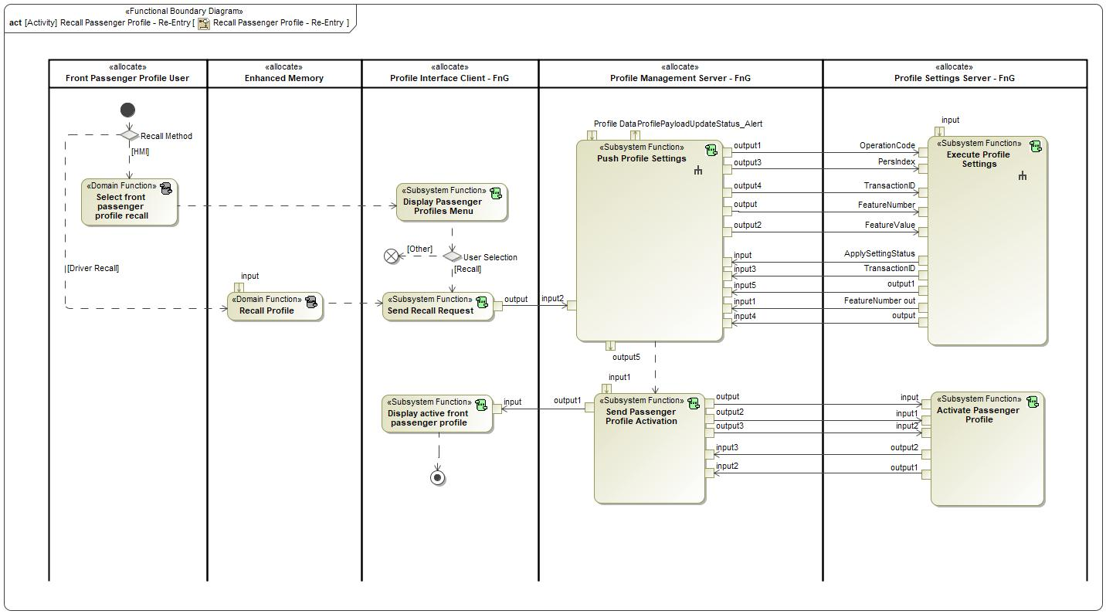

Figure Activity Diagram of  “Recall Passenger Profile - Re-Entry” calling  “Activate Passenger Profile”

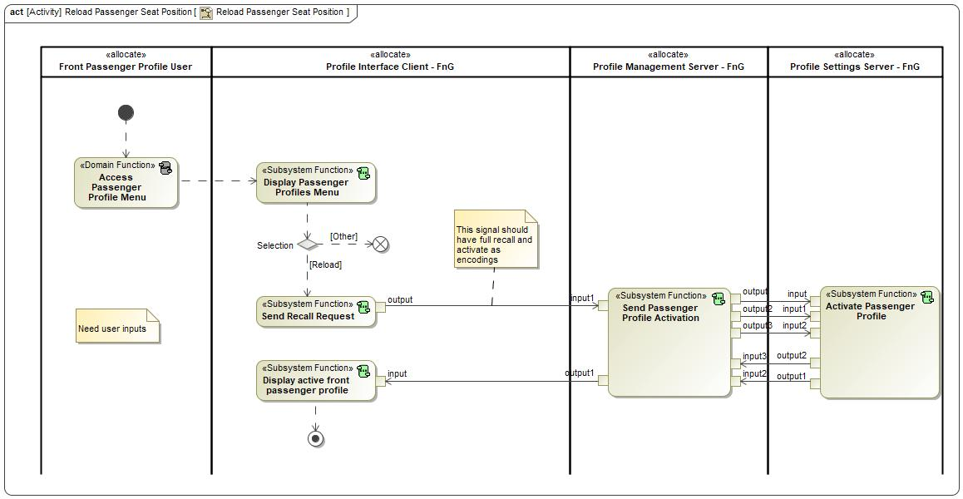

Figure : Activity Diagram of 1971981308.jpg “Reload Passenger Seat Position” calling  “Activate Passenger Profile”

### Function Interfaces

**#Link:** [RE Wiki – Adding a Logical Signal or Parameter](http://wiki.ford.com/display/RequirementsEngineering/Adding+a+Logical+Signal+or+Parameter)

#### Logical Inputs

|  |  |
| --- | --- |
| **Signal Name** | **Description** |
| input1  Type:  TransactionID | Signal Description:  Unique ID for each request that is valued 1-7. Response echo's back the same transaction ID to ensure a valid request/response transaction.  Received from:   * Send Passenger Profile Activation |
| input  Type:  OperationCode | Signal Description:  Determines which operation the Profile Setting Server is requested to execute. Depending on the operation code, the following signals could contain more or less data.  Received from:   * Send Passenger Profile Activation |
| input2  Type:  PersIndex | Signal Description:  Determines the profile number that the Profile Setting Server needs to execute an operation on.  Received from:   * Send Passenger Profile Activation |

#### Logical Outputs

|  |  |
| --- | --- |
| **Signal Name** | **Description** |
| output1  Type:  TransactionID | Signal Description:  Unique ID for each request that is valued 1-7. Response echo's back the same transaction ID to ensure a valid request/response transaction.  Sent to:   * Send Passenger Profile Activation |
| output2  Type:  1262816948.jpg ResponseStatus | Signal Description:  Determines the status of the response to a PPPSettings_Rq. The ResponseStatus can indicate if an operation is successful, in-progress, failed or if there are errors.  Sent to:   * -547695355.jpg Send Passenger Profile Activation |

#### Logical Parameters

**#Hint**: Put requirements for parameters here, which are implemented as configuration parameters using Method 2 or 3 or as parameters for calibration.

*Not supported by MagicDraw report generation.*

### Function Modeling

**#Classification:** Mandatory

**#Hint:** Typical modeling artifacts in this section are State Machines, Activity Diagrams / Flow Charts, Decision Tables, and possibly Sequence Diagrams, which can all be used as techniques to analyze the function requirements.

**#Links:** Analyze / Model Requirements: [RE Wiki – Analyze / Model Requirements](http://wiki.ford.com/pages/viewpage.action?pageId=110594919&src=contextnavpagetreemode)

#### Use Cases

**#Classification:** Infotainment Only (remove section, if not used)

**#Hint:** Some Domains (e.g. Infotainment) use not only Customer Use Cases (in the Feature Doc), but refine Use Case descriptions down to function level. In general, the RE approach encourages the use of Use Cases on Feature Level but not on Function Level. Activity Diagrams are a more suitable way to express the same on Function Level.

**#Links:** Infotainment – “Harmony Systems Engineering” Approach

*Not supported by MagicDraw report generation.*

#### State Charts / Activity Diagrams / Sequence Diagrams / Decision Tables

**#Classification:** Mandatory

**#Hint:** It is highly recommended to use at least one of the following modeling techniques for modeling and analyzing the Function behavior and derived requirements (refer to sample diagrams below):

State Machines, Activity Diagrams / Flow Charts, or Decision Tables

Optionally, Sequence Diagrams might help to analyze the interaction between Functions.

**#Links:** Analyze / Model Requirements: [RE Wiki – Analyze / Model Requirements](http://wiki.ford.com/pages/viewpage.action?pageId=110594919&src=contextnavpagetreemode)

State Charts [RE Wiki – State Charts](http://wiki.ford.com/display/RequirementsEngineering/State+Charts?src=contextnavpagetreemode)

Activity Diagrams: [RE Wiki – Activity Diagram](http://wiki.ford.com/display/RequirementsEngineering/Activity+Diagram?src=contextnavpagetreemode), [SysML User Group – Activity Diagram Basics](https://pd3.spt.ford.com/sites/SystemsEngineering/SEC/sysml-teamsite/SysML%20Wiki/Activity%20Diagram%20Basics.aspx)

Sequence Diagrams: [RE Wiki – Sequence Chart](http://wiki.ford.com/display/RequirementsEngineering/Sequence+Chart?src=contextnavpagetreemode), [SysML User Group – Sequence Diagram Basics](https://pd3.spt.ford.com/sites/SystemsEngineering/SEC/sysml-teamsite/SysML%20Wiki/Sequence%20Diagram%20Basics.aspx)

No diagrams internal to function specified.

### Function Requirements

#Link: [*RE Wiki – How to write good requirements*](http://wiki.ford.com/display/RequirementsEngineering/How+to+write+better+requirements?src=contextnavpagetreemode)

#### Functional Requirements

***#Hint:*** *Please also consider specific situations like Initialization (Startup) and Deinitialization (Shutdown) apart from Normal Operation and Error Handling. E.g. a* state chart or activity diagram might help for better understanding.

##### Normal Operation

Receiving Passenger Profile Activation Request

When the Passenger Profile Setting Server receives an Activate Profile request via the PPPSettings_Rq with the signal values below, the Profile Setting Server shall recall the requested PersIndex that was sent in the PPPSetting_Rq.

- OperationCode = ACTIVATE

- PersIndex = PERS_1/2/3/4 or VEHICLE

- TransactionID = 0x0 - 0x7

- FeatureNumber = Don't Care

- FeatureValue = Don't Care

|  |  |  |  |  |  |  |  |
| --- | --- | --- | --- | --- | --- | --- | --- |
| Requirement ID: | | | | | | | |
| **Rationale** |  | | | | | | |
| **Acceptance Criteria** |  | | | | | | |
| **Notes** |  | | | | | | |
| **Source** |  | | | | | **Owner** |  |
| **Source Req.** |  | | | | | **V&V Method** |  |
| **Type** |  | | | **Priority** |  | **Status** |  |
| [Req. Template](http://wiki.ford.com/display/RequirementsEngineering/Requirements+Attributes) Version | | 6.0 | End of Requirement | | | | |

Responding to Activate Passenger Profile request

When the Passenger Profile Setting Server receives ACTIVATE request from the Profile Management Server, the Profile Setting Server shall send the following responses depending on the associated criteria:

- ResponseStatus = SUCCESS when passenger profile successfully activated

- ResponseStatus = FAILED when the requested profile is unable to be activated

- ResponseStatus = INVALID when the request contains invalid parameters (REQ-405863)

|  |  |  |  |  |  |  |  |
| --- | --- | --- | --- | --- | --- | --- | --- |
| Requirement ID: | | | | | | | |
| **Rationale** |  | | | | | | |
| **Acceptance Criteria** |  | | | | | | |
| **Notes** |  | | | | | | |
| **Source** |  | | | | | **Owner** |  |
| **Source Req.** |  | | | | | **V&V Method** |  |
| **Type** |  | | | **Priority** |  | **Status** |  |
| [Req. Template](http://wiki.ford.com/display/RequirementsEngineering/Requirements+Attributes) Version | | 6.0 | End of Requirement | | | | |

Sending recall request after receiving Activation request – PSM Only

After the Profile Setting Server (PSM) receives the ACTIVATE request via the PPPSettings_Rq from the Profile Management Server, the Profile Setting Server (PSM) shall execute the recall and send the classic memory recall request for the requested PersIndex received in the PPPSettings_Rq.

|  |  |  |  |  |  |  |  |
| --- | --- | --- | --- | --- | --- | --- | --- |
| Requirement ID: | | | | | | | |
| **Rationale** |  | | | | | | |
| **Acceptance Criteria** |  | | | | | | |
| **Notes** |  | | | | | | |
| **Source** |  | | | | | **Owner** |  |
| **Source Req.** |  | | | | | **V&V Method** |  |
| **Type** |  | | | **Priority** |  | **Status** |  |
| [Req. Template](http://wiki.ford.com/display/RequirementsEngineering/Requirements+Attributes) Version | | 6.0 | End of Requirement | | | | |

##### Error Handling

***#Hint:*** *FMEA counter measures could be considered as requirements in this chapter*

No Error Handling Requirements specified.

#### Non-Functional Requirements

***#Hint:*** *Non-functional requirements specify some performance criteria in addition to the functional behavior given defined by the functional requirements. Timing (if not already included in the functional requirements), security details (e.g. how secure does an algorithm have to be) or reliability (e.g. mean time between failure) could be specified in this section.*

No Non-Functional Requirements specified.

#### Functional Safety Requirements

**#Classification**: Functional Safety only – If not used, remove content and state “Not Applicable”

***#Hint:*** *Add Functional Safety Requirements (FSRs) derived for this function.*

**#Link:** [Functional Safety Sharepoint](https://pd3.spt.ford.com/sites/GlobalFunctionalSafety/Pages/default.aspx) – Functional Safety Concept

[RE Wiki - Requirements Attributes](http://wiki.ford.com/display/RequirementsEngineering/Requirements+Attributes)

No Functional Safety Requirements specified.

##### ASIL Decomposition of Functional Safety Requirements

**#Classification**: Functional Safety only – If not used, remove content and state “Not Applicable”

***#Hint:*** *Sometimes an ASIL decomposition of Functional Safety Requirements is required. The decomposed FSRs should be listed beneath each ASIL Decomposition table below and referenced inside the table by ID and Title*

**#Link:** [Functional Safety Sharepoint](https://pd3.spt.ford.com/sites/GlobalFunctionalSafety/Pages/default.aspx) – Functional Safety Concept

No Functional Safety Requirements with ASIL Decompositions specified.

#### Other Requirements

##### Design Requirements

***#Hint:*** *Requirements of a Logical Function should be typically agnostic of their SW/HW implementation*. If for specific reasons the function owner needs to define explicitly design constraints, it can be done in this chapter.

No Design Requirements specified.

## Store passenger seat from Infotainment Request - Passenger Seat Module Only

### Function Overview

#### Description

Function is allocated to:

* 1716959969.jpg Front Passenger Profiles <<Feature>>
* -960180345.jpg Profile Settings Server - FnG <<Logical>>

Function that stores the current seat position to the requested PersIndex when the InfotainmentPsngrPersStore_Rq is received.

#### Variants

*Not supported by MagicDraw report generation.*

#### Input Requirements

*Not supported by MagicDraw report generation.*

#### Assumptions

No assumptions specified for this function.

#### References

##### Ford Documents

List here all Ford internal documents, which are directly related to the feature.

| **Reference** | **Title** | **Doc. ID** | **Revision** |
| --- | --- | --- | --- |
|  |  |  |  |

Table 5: Ford internal Documents *(not specified in model)*

##### External Documents and Publications

The list of external documents could include books, reports and online sources.

| **Reference** | **Document / Publication** |
| --- | --- |
|  |  |

Table 7: External documents and publications *(not specified in model)*

#### Glossary

See Appendix for Definitions and Abbreviations.

### Function Scope

The  **– “Store passenger seat from Infotainment Request - Passenger Seat Module Only”** function is called by the following functions:

*  – “Create Passenger Profile via HMI - First Entry”
*  – “Manual Save Passenger Seat Position”

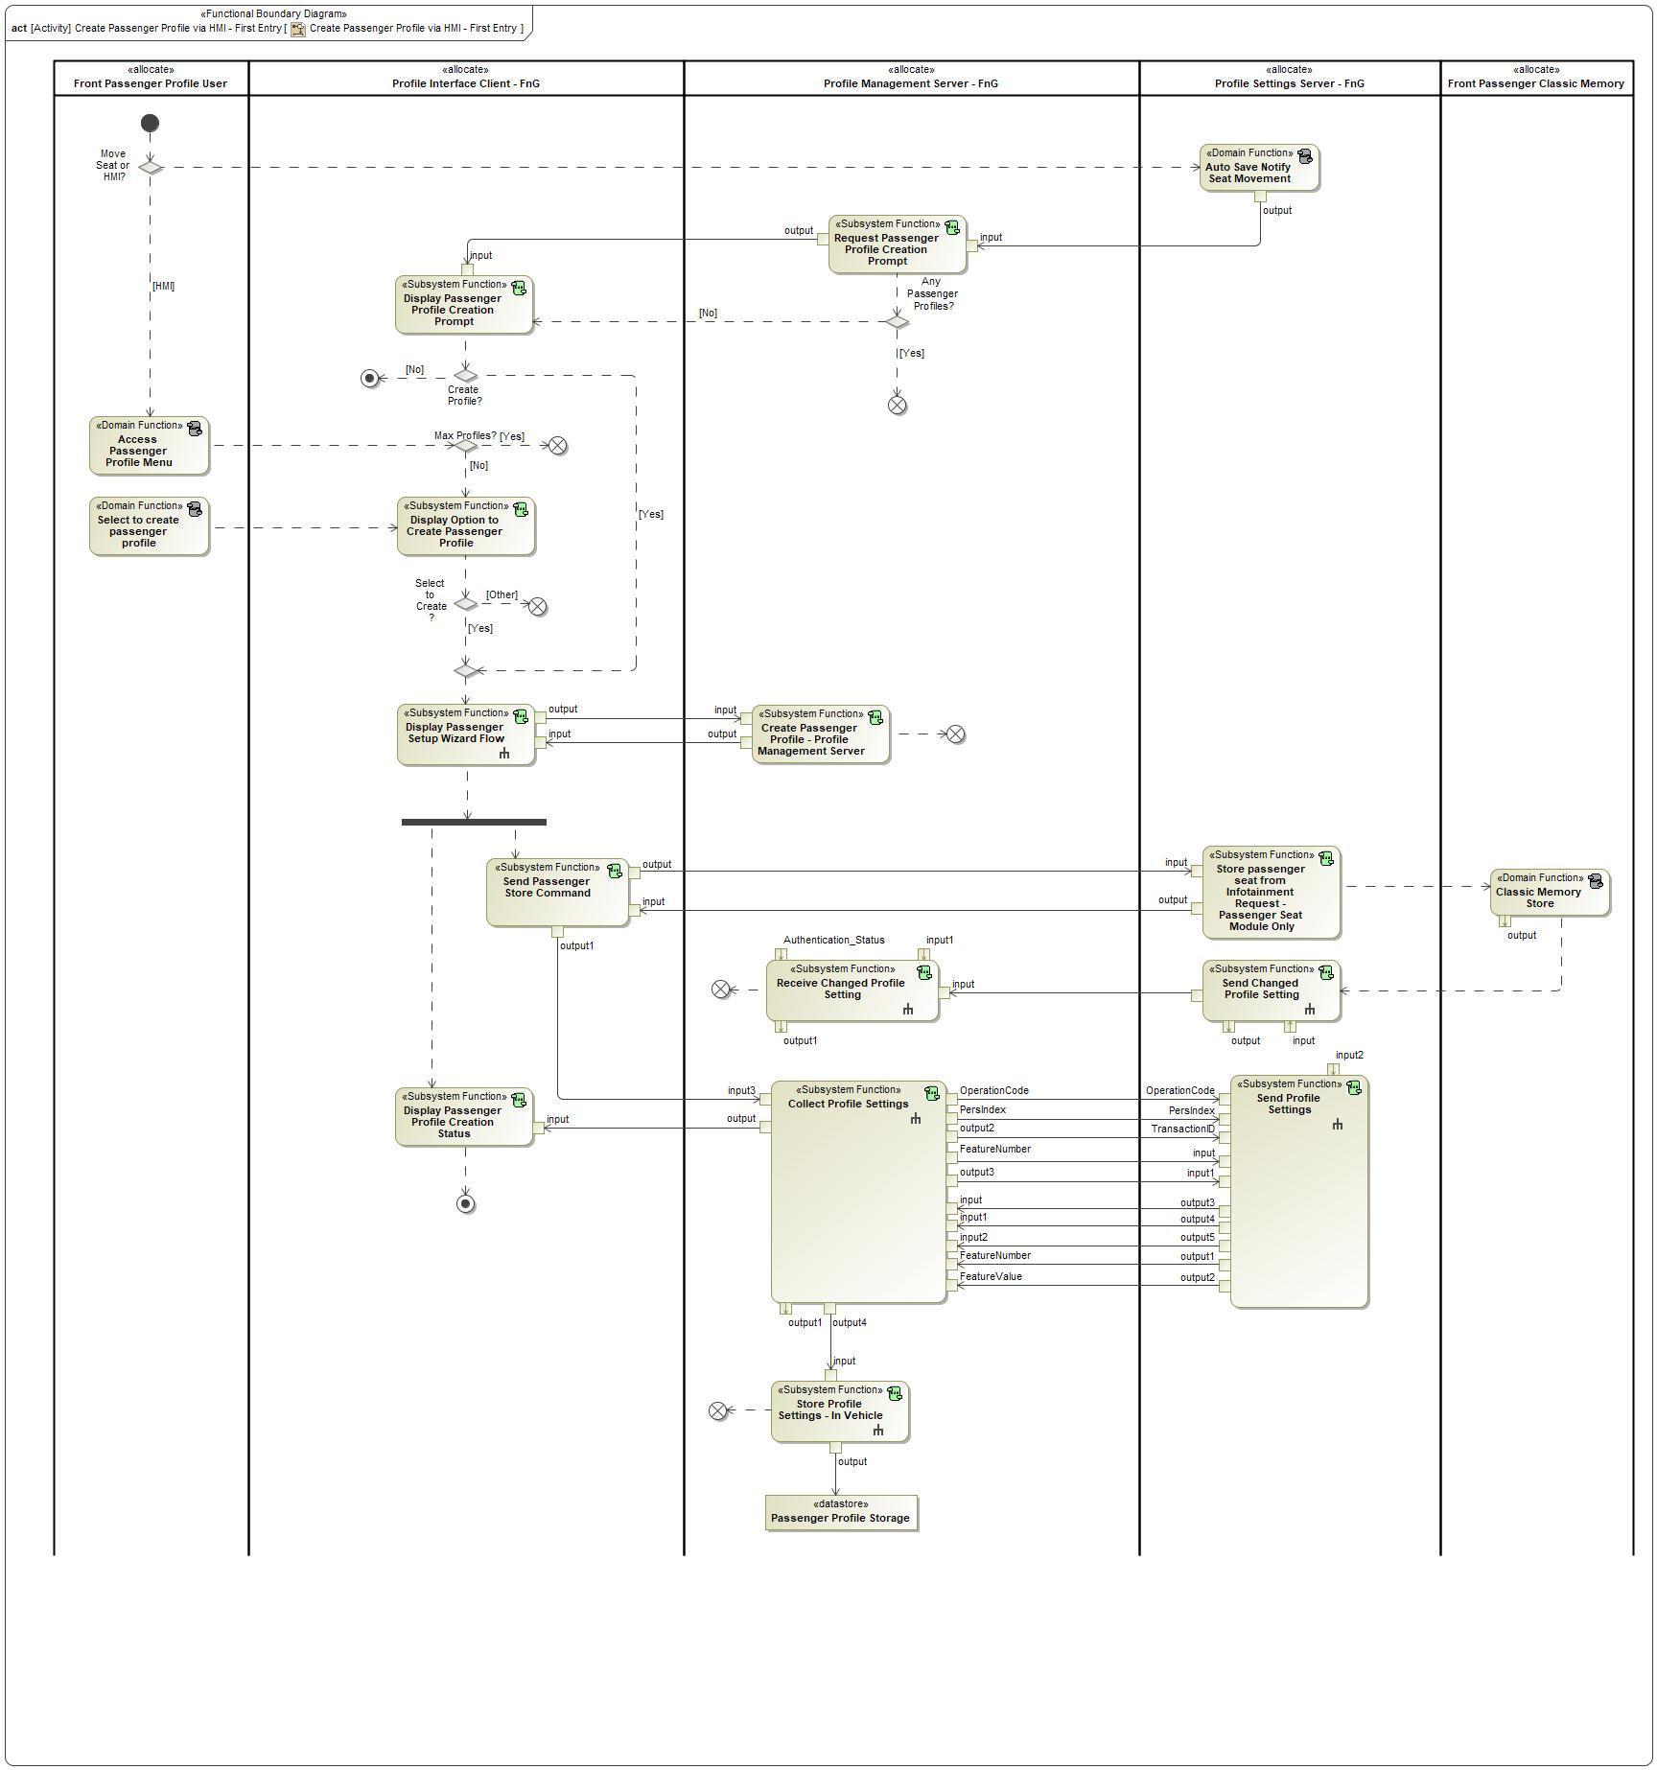

Figure : Activity Diagram of  “Create Passenger Profile via HMI - First Entry” calling  “Store passenger seat from Infotainment Request - Passenger Seat Module Only”

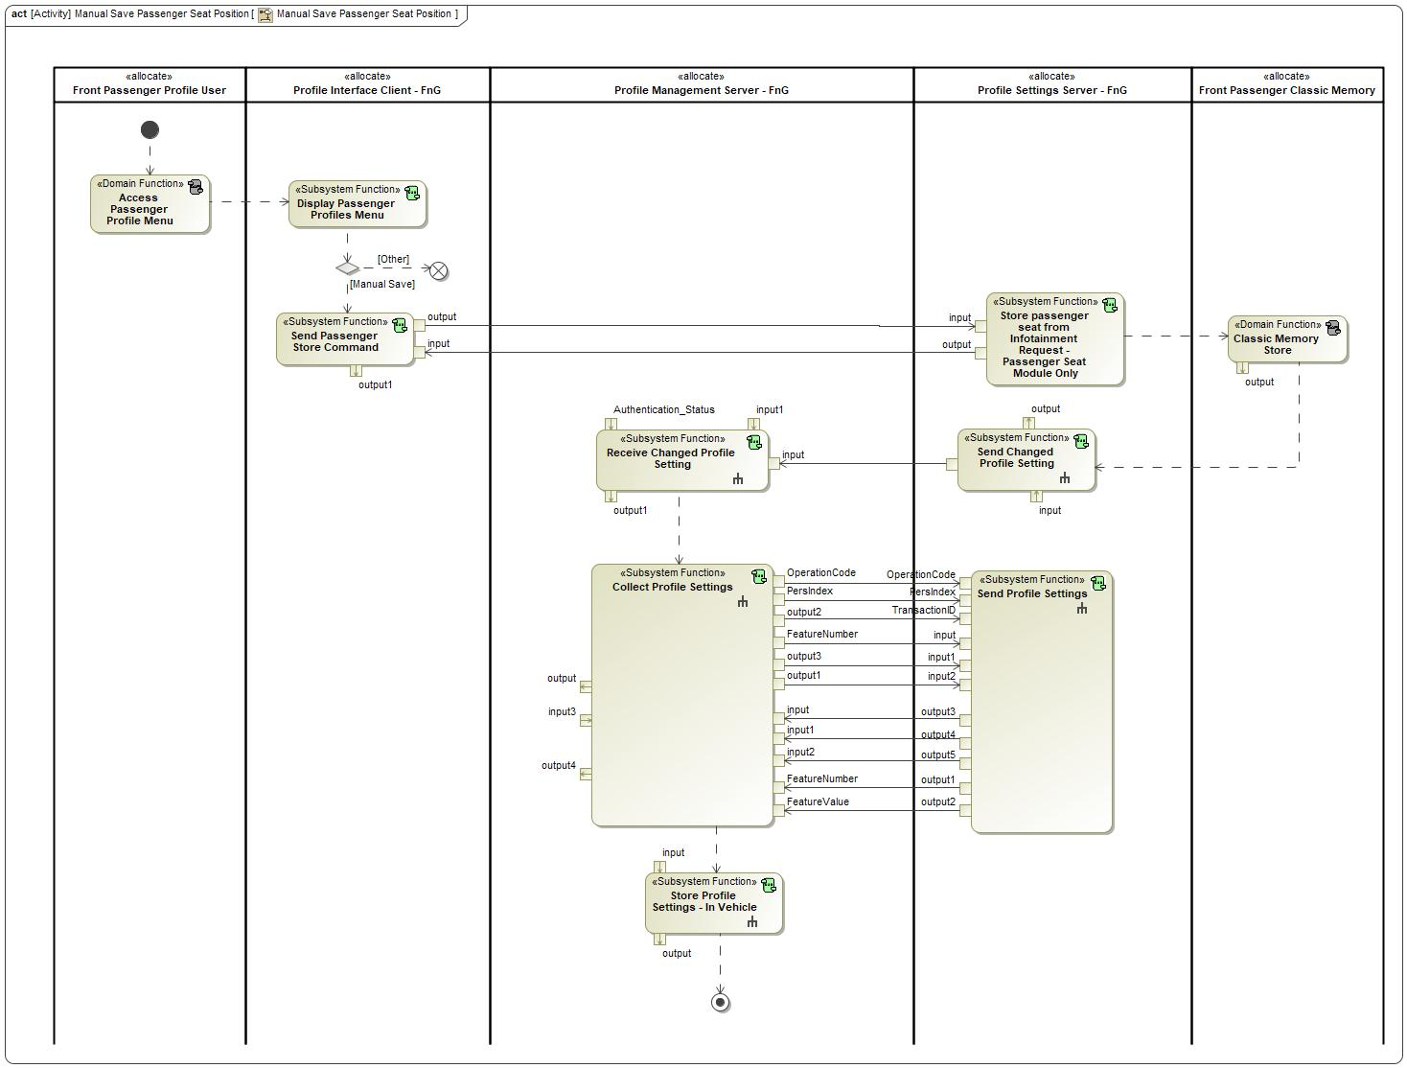

Figure : Activity Diagram of 1971981308.jpg “Manual Save Passenger Seat Position” calling 1179395554.jpg “Store passenger seat from Infotainment Request - Passenger Seat Module Only”

### Function Interfaces

#### Logical Inputs

|  |  |
| --- | --- |
| **Signal Name** | **Description** |
| input  Type:  InfotainmentPsngrPersStore_Rq | Signal Description:  The signal is used by the Profile Interface Client to request current passenger classic memory settings to be stored to the indicated personality profile.  Received from:   * Send Passenger Store Command |

#### Logical Outputs

|  |  |
| --- | --- |
| **Signal Name** | **Description** |
| output  Type:  966209822.jpg InfotainmentPsngrPersStore_St | Signal Description:  The signal is used to inform the Profile Interface Client the status of a requested store event.  Sent to:   * -270231351.jpg Send Passenger Store Command |

#### Logical Parameters

*Not supported by MagicDraw report generation.*

### Function Modeling

#### Use Cases

*Not supported by MagicDraw report generation.*

#### State Charts / Activity Diagrams / Sequence Diagrams / Decision Tables

No diagrams internal to function specified.

### Function Requirements

#### Functional Requirements

##### Normal Operation

Passenger Profile Setting Server receiving InfotainmentPsngrPersStore_Rq (Passenger Seat Module Only)

When the Passenger Seat Controller receives InfotainmentPsngrPersStore_Rq, the Passenger Seat Controller shall do the following:

- store the current seat position to the requested PersIndex.

- Broadcast SeatPsngrMem_D_Cmd for the requested PersIndex

|  |  |  |  |  |  |  |  |
| --- | --- | --- | --- | --- | --- | --- | --- |
| Requirement ID: | | | | | | | |
| **Rationale** |  | | | | | | |
| **Acceptance Criteria** |  | | | | | | |
| **Notes** |  | | | | | | |
| **Source** |  | | | | | **Owner** |  |
| **Source Req.** |  | | | | | **V&V Method** |  |
| **Type** |  | | | **Priority** |  | **Status** |  |
| [Req. Template](http://wiki.ford.com/display/RequirementsEngineering/Requirements+Attributes) Version | | 6.0 | End of Requirement | | | | |

Responding to InfotainmentPsngrPersStore_Rq (Passenger Seat Module Only)

The Passenger Seat Controller shall respond to the InfotainmentPsngrPersStore_Rq with the following:

- InfotainmentPsngrPersStore_St = InProgress: while the store operation is being performed

- InfotainmentPsngrPersStore_St = Complete: when complete.

|  |  |  |  |  |  |  |  |
| --- | --- | --- | --- | --- | --- | --- | --- |
| Requirement ID: | | | | | | | |
| **Rationale** |  | | | | | | |
| **Acceptance Criteria** |  | | | | | | |
| **Notes** |  | | | | | | |
| **Source** |  | | | | | **Owner** |  |
| **Source Req.** |  | | | | | **V&V Method** |  |
| **Type** |  | | | **Priority** |  | **Status** |  |
| [Req. Template](http://wiki.ford.com/display/RequirementsEngineering/Requirements+Attributes) Version | | 6.0 | End of Requirement | | | | |

Return to Null State - InfotainmentPsngrPersStore_St (Passenger Seat Module Only)

When updating on an event, InfotainmentPsngrPersStore_St shall hold its encoding values for a period of time defined by T_ReturnToNull and then shall transit back to Null.

|  |  |  |  |  |  |  |  |
| --- | --- | --- | --- | --- | --- | --- | --- |
| Requirement ID: | | | | | | | |
| **Rationale** |  | | | | | | |
| **Acceptance Criteria** |  | | | | | | |
| **Notes** |  | | | | | | |
| **Source** |  | | | | | **Owner** |  |
| **Source Req.** |  | | | | | **V&V Method** |  |
| **Type** |  | | | **Priority** |  | **Status** |  |
| [Req. Template](http://wiki.ford.com/display/RequirementsEngineering/Requirements+Attributes) Version | | 6.0 | End of Requirement | | | | |

##### Error Handling

No Error Handling Requirements specified.

#### Non-Functional Requirements

No Non-Functional Requirements specified.

#### Functional Safety Requirements

No Functional Safety Requirements specified.

##### ASIL Decomposition of Functional Safety Requirements

No Functional Safety Requirements with ASIL Decompositions specified.

#### Other Requirements

##### Design Requirements

No Design Requirements specified.

# Open Concerns

**#Hint:** The following list presents open concerns, which have to be discussed or clarified over the course of the on-going requirements engineering.

| ID | Concern Description | e-Tracker / Reference | Responsible | Status | Solution |
| --- | --- | --- | --- | --- | --- |
| 1 |  |  |  |  |  |

Table 9: Open Concerns *(Not supported by MagicDraw report generation.)*

# Revision History

**#Hint:** A new version number is assigned to a document with a given revision each time it is checked in to Team Center (TCSE). After release of a revision, the document cannot be edited and no new versions can be created on that revision. When updating the document after that, a new revision has to be created and new versions on that revision will be created upon checking in.

|  |  |  |  |  |
| --- | --- | --- | --- | --- |
| **Version** | **Rev.** | **Date** | **Description** | **Responsible** |
| 1 | 0 | 2021-03-10 | Initial version. | Jbauer50 |
| 1 | 1 | 2021-06-02 | * Changed ApplySettingStatus to ResponseStatus * Revised logical signals to match Personalization Service signal encodings * “Send Changed Profile Setting” function flow changed to follow change notification strategy * Revised function descriptions * Added sequence diagrams for each function * Added logical parameter SettingCountTotal | Jbauer50 |
| 1 | 2 | 2021-09-15 | * Removed PersIndex signal from REQ-421983. * Changed “Send All Profile Settings” function name to “Send Profile Settings” * Added logical signal ProfileMode * Added logical parameter PPPSetTime * Added logical parameter PPPQueryRspTime * Updated Execute Profile Settings Activity Diagram * Updated Send Profile Settings Activity Diagram * Updated Send Changed Profile Setting Activity Diagram * Added Execute Profile Settings – FAILED and Execute Profile Settings – INVALID sequence diagram * Clarified text on many requirements * Removed REQ-352219 * Removed REQ-405855 * Removed REQ-405862 * Removed REQ-405866 * Changed the name of REQ-405863 * Changed name and text of REQ-352239 | Jbauer50 |
| 1 | 3 | 2021-10-1 | * Added Passenger Profile Functions: Activate Passenger Profile and Store Passenger Seat from Infotainment Request – Passenger Seat Module Only * New requirements for above functions * Added 2 new logical signals: InfotainmentPsngrPersStore_Rq and InfotainmentPsngrPersStore_St * Added new encoding for OperationCode: ACTIVATE | Jbauer50 |

## Template Revisions

*#Important: Do not change this section*

|  |  |  |  |  |
| --- | --- | --- | --- | --- |
| Version | Rev. | Date | Description | Responsible |
| *1* | *0* | *2016-02-26* | *Initial version, derived from FDS* | *Jbaden1* |
| *1* | *1* | *2016-02-26* | *Word properties corrected* | *Jbaden1* |
| *1* | *2* | *2016-03-10* | *Clean up of document meta data (Word properties)* | *Jbaden1* |
| *1* | *3* | *2016-03-22* | * *Footer formatting corrected (Issue 19)* * *“Constraints” chapter renamed to “Input Requirements” (Issue 20)* | *Jbaden1* |
| *1* | *4* | *2016-04-20* | * *Broken Wiki links repaired* | *Jbaden1* |
| *2* | *0* | *2016-06-10* | * *Document metadata adapted. Prepared for new macros* * *DTC table removed* * *HMI function added as a chapter (details still to be refined)* * *Signal / Parameter IDs column deleted interface tables* | *Jbaden1* |
| *2* | *1* | *2016-07-14* | * *Converted to SysML diagrams* * *HMI section further elaborated* * *Template version added to footer* * *Dedicated Startup / Shutdown sections removed (only hints added)* * *Data Dictionary reworked and Signal / Parameter IDs column re-introduced* | *Jbaden1* |
| *2* | *2* | *2016-12-07* | * *Minor formatting changes* | *Jbaden1* |
| *3* |  |  | *Skipped to synchronize with Specification_Macros.dotm* |  |
| *4* |  |
| *5* | *0* | *2017-01-13* | * *Meta data updated for specification macros, version 3.1* * *SW Unit chapter removed for the time being* * *Green boxes added for user hints* | *Jbaden1* |
| *5* | *1* | *2017-01-18* | * *Some additional hints.* * *Hyperlinks highlighted in hints* | *Jbaden1* |
| *6* | *0* | *2017-04-28* | * *Editorial change. Hints added to chapter 4.1.4* * *Chapter “Traceability Matrix” removed* | *Jbaden1* |
| *6* | *0* | *2018-04-28* | * *CR69/63: New chapters added for Functional Safety (FTTI and Technical Safety Requirements)* * *CR53: New coversheet + additional meta-data* * *CR76: merge sections for configuration and for calibration parameters into one on Function Level* | *Jbaden1* |
| *6* | *0* | *2018-08-06* | * *CR66: Fix version numbering in footer of Function Spec* | *Jbaden1* |
| *6* | *0* | *2018-09-28* | * *Broken links to RE Wiki repaired* | *Jbaden1* |
| *6* | *0* | *2018-10-31* | * *Minor corrections on cover sheet and in footer to be more GIS compliant and VSEM aligned* * *“Overview” and “Description” exchanged in headings (following common sense)* | *Jbaden1* |
| *6* | *0* | *2018-11-12* | * *Explanatory text in Variants” section revised* * *Functional Safety modifications as agreed with FuSa core team (Baseline: November 2018 Dearborn On-Site)* | *Jbaden1* |
| *M* |  | *2019-04-02* | * *Initial version of SysML report template* | *snuesch* |
| *M* |  | *2019-04-05* | * *Improved dialog boxes to select function group* | *snuesch* |
| *M* |  | *2019-04-26* | * *Improved function interfaces (support of additional elements (e.g., send signal action, add structural feature action, merge node, decision node, activity parameter nodes, etc.) and pins)* | *snuesch* |
| *N* |  | *2019-08-19* | * *For each function now also requirements satisfied by activity parameter nodes and function outputs are populated.* | *snuesch* |
| *N* |  | *2019-08-21* | * *Improved glossary and acronym tables* | *snuesch* |
| *N* |  | *2019-09-20* | * *Updated Function Interfaces tables with better wording. Added a report template variable that allows to disable senders and receivers. Sorted requirements by ID.* | *snuesch* |
| *N* |  | *2019-09-27* | * *Green hints now only show up for first function.* * *labelTag variable can be used to filter revision history.* | *snuesch* |

# Appendix

## Data Dictionary

### Logical Signals

**#Macro:** [Add Ins -> Add Requirement macro](http://wiki.ford.com/display/RequirementsEngineering/Adding+a+Logical+Signal+or+Parameter) (select “Logical Signal” as type)

ResponseStatus

Determines if a profile setting had successfully been set by the Profile Setting Server.

|  |  |  |
| --- | --- | --- |
| **ASIL** | | QM |
| **Encoding Type Name** | | Discrete |
| Note: An encoding is either discrete or continuous. Delete fields below which are not needed | | |
| **Value**  (Discrete  Encoding) | 0x0 | NULL |
| 0x1 | SUCCESS |
| 0x2 | PENDING (Not used for PPP) |
| 0x3 | REJECTED (Not used for PPP) |
| 0x4 | INTERRUPTED (Not used for PPP) |
| 0x5 | FAILED |
| 0x6 | IN_PROG |
| 0x7 | INVALID |
| 0x8 | NotUsed_1 |
| 0x9 | NotUsed_2 |
| 0xA | NotUsed_3 |
| 0xB | NotUsed_4 |
| 0xC | NotUsed_5 |
| 0xD | NotUsed_6 |
| 0xE | NotUsed_7 |
| 0xF | FAULT (Not used for PPP) |
| **Unit** | |  |

Change_Notification

Notifies the Profile Management Server that a change has been made to the active profile.

|  |  |  |
| --- | --- | --- |
| **ASIL** | | QM |
| **Encoding Type Name** | | Discrete |
| Note: An encoding is either discrete or continuous. Delete fields below which are not needed | | |
| **Value**  (Discrete  Encoding) | 0x0 | NULL |
| 0x1 | PROFILE_UPDATED |
| 0x2 | DATA_LOST (Not used for PPP) |
| **Unit** | |  |

FeatureNumber

Signal that carries the hexadecimal values assigned to each setting that is stored in the profile.

|  |  |  |
| --- | --- | --- |
| **ASIL** | | QM |
| **Encoding Type Name** | | Continuous |
| Note: An encoding is either discrete or continuous. Delete fields below which are not needed | | |
| **Value**  (Continuous Encoding) | Min Value | 0x0000 |
| Max Value | 0xFFFF |
| Resolution | 0x1 |
| Offset | None |
| **Unit** | |  |

FeatureValue

Carries the setting configuration for a Feature Number. Feature Numbers and Feature Values are always paired together.

|  |  |  |
| --- | --- | --- |
| **ASIL** | | QM |
| **Encoding Type Name** | | Continuous |
| Note: An encoding is either discrete or continuous. Delete fields below which are not needed | | |
| **Value**  (Continuous Encoding) | Min Value | 0x0000 |
| Max Value | 0xFFFF |
| Resolution | 0x1 |
| Offset | None |
| **Unit** | |  |

OperationCode

Determines which operation the Profile Setting Server is requested to execute. Depending on the operation code, the following signals could contain more or less data.

|  |  |  |
| --- | --- | --- |
| **ASIL** | | QM |
| **Encoding Type Name** | | Discrete |
| Note: An encoding is either discrete or continuous. Delete fields below which are not needed | | |
| **Value**  (Discrete  Encoding) | 0x0 | NULL |
| 0x1 | QUERY |
| 0x2 | SET |
| 0x3 | UPLOAD (Not used for PPP) |
| 0x4 | RESTORE (Not used for PPP) |
| 0x5 | COPY (Not used for PPP) |
| 0x6 | ACTIVATE |
| 0x7 | NotUsed_2 |
| **Unit** | |  |

PersIndex

Determines the profile number that the Profile Setting Server needs to execute an operation on.

|  |  |  |
| --- | --- | --- |
| **ASIL** | | QM |
| **Encoding Type Name** | | Discrete |
| Note: An encoding is either discrete or continuous. Delete fields below which are not needed | | |
| **Value**  (Discrete  Encoding) | 0x0 | PERS_1 |
| 0x1 | PERS_2 |
| 0x2 | PERS_3 |
| 0x3 | PERS_4 |
| 0x4 | VEHICLE |
| 0x5 | NotUsed_1 |
| 0x6 | NotUsed_2 |
| 0x7 | NotUsed_3 |
| **Unit** | |  |

TransactionID

Unique ID for each request that is valued 1-7. Response echo's back the same transaction ID to ensure a valid request/response transaction.

|  |  |  |
| --- | --- | --- |
| **ASIL** | | QM |
| **Encoding Type Name** | | Continuous |
| Note: An encoding is either discrete or continuous. Delete fields below which are not needed | | |
| **Value**  (Continuous Encoding) | Min Value | 0 (0x0) |
| Max Value | 7 (0x7) |
| Resolution | 1 (0x1) |
| Offset | None |
| **Unit** | |  |

SettingCount

Number of profile settings remaining to be sent to the Profile Management Server.

|  |  |  |
| --- | --- | --- |
| **ASIL** | | QM |
| **Encoding Type Name** | | Continuous |
| Note: An encoding is either discrete or continuous. Delete fields below which are not needed | | |
| **Value**  (Continuous Encoding) | Min Value | 0 (0x0) |
| Max Value | 31 (0x1F) |
| Resolution | 1 (0x1) |
| Offset | None |
| **Unit** | |  |

ProfileMode

Notifies the Profile Management Server that a change has been made to the active profile.

|  |  |  |
| --- | --- | --- |
| **ASIL** | | QM |
| **Encoding Type Name** | | Discrete |
| Note: An encoding is either discrete or continuous. Delete fields below which are not needed | | |
| **Value**  (Discrete  Encoding) | 0x0 | NULL |
| 0x1 | PERSONALIZED |
| 0x2 | REJUVENATE_RELAX |
|  | 0x3 | REJUVENATE_INVIGORATE |
|  | 0x4 | SSW_WORK |
|  | 0x5 | NotUsed_1 |
|  | 0x6 | NotUsed_2 |
|  | 0x7 | NotUsed_3 |
| **Unit** | |  |

InfotainmentPsngrPersStore_Rq

Request to do a classic memory store for passenger positional settings.

|  |  |  |
| --- | --- | --- |
| **ASIL** | | QM |
| **Encoding Type Name** | | Discrete |
| Note: An encoding is either discrete or continuous. Delete fields below which are not needed | | |
| **Value**  (Discrete  Encoding) | 0x0 | NULL |
| 0x1 | PERS_1 |
| 0x2 | PERS_2 |
| 0x3 | PERS_3 |
| 0x4 | PERS_4 |
| 0x5 | VEHICLE |
| **Unit** | |  |

InfotainmentPsngrPersStore_St

Status response to the InfotainmentPsngrPersStore_Rq.

|  |  |  |
| --- | --- | --- |
| **ASIL** | | QM |
| **Encoding Type Name** | | Discrete |
| Note: An encoding is either discrete or continuous. Delete fields below which are not needed | | |
| **Value**  (Discrete  Encoding) | 0x0 | COMPLETE |
| 0x1 | InProgress |
| 0x2 | NULL |
| **Unit** | |  |

### Logical Parameters

**#Macro:** [Add Ins -> Add Requirement macro](http://wiki.ford.com/display/RequirementsEngineering/Adding+a+Logical+Signal+or+Parameter) (select “Logical Parameter” as type)

###LPR_SettingCountTotal_00001### LPR_SettingCountTotal

Total amount of profile feature numbers that a Profile Setting Server controls.

|  |  |  |
| --- | --- | --- |
| **Encoding Type Name** | |  |
| Note: An encoding is either discrete or continuous. Delete fields below which are not needed, | | |
| **Value**  (Continuous Encoding) | Min Value | 0 |
| Max Value | 1000 |
| Resolution | 1 |
| Offset | 0 |
| **Unit** | |  |

###LPR_PPPSetTime_00002### LPR_PPPSetTime

Maximum time the Profile Setting Server should take to Set a received FeatureNumber-FeatureValue pair and respond with a status back to the Profile Management Server.

Note: Use the default value

|  |  |  |  |  |  |
| --- | --- | --- | --- | --- | --- |
| **Name** | **Description** | **Units** | **Range** | **Resolution** | **Default** |
| PPPSetTime | Maximum time the Profile Setting Server should take to Set a received FeatureNumber-FeatureValue pair and respond with a status back to the Profile Management Server.  Note: Use the default value | msec | 50-150 | 5 | 75 |

###LPR_PPPQueryRspTime_00003### LPR_PPPQueryRspTime

Maximum time the Profile Setting Server should take to send a new FeatureNumber – FeatureValue pair to the Profile Management Server after a QUERY request

Note: Use the default value

|  |  |  |  |  |  |
| --- | --- | --- | --- | --- | --- |
| **Name** | **Description** | **Units** | **Range** | **Resolution** | **Default** |
| PPPQueryRspTime | Maximum time the Profile Setting Server should take to send a new FeatureNumber – FeatureValue pair to the Profile Management Server after a QUERY request  Note: Use the default value | msec | 50-150 | 5 | 100 |

### Encoding Types

**#Macro:** [Add Ins -> Add Requirement macro](http://wiki.ford.com/display/RequirementsEngineering/Adding+an+Encoding+Type) (select “Encoding Type” as type)

## Glossary

**#Hint**: Terms, concepts and abbreviations used in the document shall be defined and illustrated here. Note that changes to terms and/or concepts described in this section tend to cause major updates to this document.

The tables below have feature specific definitions and abbreviations. For additional, non-feature specific terms please refer to the [RE Glossary](http://wiki.ford.com/display/RequirementsEngineering/Glossary?src=contextnavpagetreemode)

### Definitions

**#Hint:** The table below has definitions and abbreviations relevant for the functions in this document. For additional terms please refer to the [RE Glossary](http://wiki.ford.com/display/RequirementsEngineering/Glossary?src=contextnavpagetreemode)

| **Definition** | **Description** |
| --- | --- |
| EM Profile Server | Logical block of the Enhanced Memory system that is responsible for determining the active profile. |
| Feature Number | A hexadecimal value assigned to a profile setting. This was established by the Feature Based Message Protocol (FBMP) and is used by PPP to create a common understanding of what the profile settings are between vehicles. |
| Feature Value | Determine the status of the active setting. For example, Easy Entry/Exit can be configured ON or OFF or a profile, the feature value can be either ON 0x01 or OFF 0x00. |
| HMI Client | The technology used to display a profile setting's current status to the user. Example, radio stations are displayed to the customer using the SYNC screen as an HMI client, but the stations are stored in the Audio Head Unit. |
| Pers Index | The index number provided to a profile in the vehicle. This helps determine which profile is activated throughout the vehicle. |
| PPP | Personal and Portable Profiles |
| Profile Setting Servers | The Profile Setting Server logical block is a generic term for any vehicle module that owns the execution and storage of profile settings. |
| Profile Settings | All user configurable settings in the vehicle that can be added to the user's profile. Examples include radio stations, ADAS settings, Ambient Light, etc. |

Table 10: Definitions used in this document

### Abbreviations

No acronyms specified.

Document ends here.